



USER MANUAL - 2024

Gujarat-Energy Conservation and Sustainability Building Code

Table of Contents
Table of Contents 1
List of Figures 2
1 Introduction 4
1.1 About ECSBC tool 4
1.2 Who Should Use It? 4
2 ECSBC Tool Interface 4
2.1 Introducing Home Page 4
2.2 Signing Up 5
2.3 Signing In 7
2.4 Forgot Password 8
2.5 User Dashboard 10
2.6 Register a new project 10
2.7 Project Details Page 12
2.7.1 Project Level Information 12
2.7.2 Block Level Information 19
2.7.2.1 Building Envelope 19
2.7.2.2 Indoor Electrical Use 32
2.7.2.3 Building Services 34
2.7.2.4 Renewable Energy 44
2.7.3 Certificate Level Information 46

List of Figures
Figure 1: Home Page 5
Figure 2: Sign-Up level 6
Figure 3: Sign-In level 8
Figure 4: Forgot Password 8
Figure 5 : Reset password form 9
Figure 6: User Dashboard 10
Figure 7: Register a new project form 11
Figure 8 : Project Details form 13
Figure 9 : Category details form 14
Figure 10 : Add other DU type when adding dwelling unit information 15
Figure 11 : Show representative blocks in navigation view 16
Figure 12 : Add a new block to a project 17
Figure 13 : Validation check when moving to block level 18
Figure 14 : Move to block level information 18
Figure 15 : Uploaded block plan will be shown on canvas 19
Figure 16 : Form to add wall material type in directions for a block 21
Figure 17 : Create custom wall type using properties method 21
Figure 18 : Create custom wall type using layers method 22
Figure 19 : Add custom window type for a project 23
Figure 20 : Created window will be seen in navigation view under Windows dropdown. 23
Figure 21 : form when adding windows to a block 24
Figure 22 : Create custom ventilator type for project 25
Figure 23 : Ventilator types created will be listed under ’Ventilators’ dropdown in navigation panel 26
Figure 24 : form to be filled when adding ventilator to block 26
Figure 25 : Create custom door type for project 27
Figure 26 : Created door types will be listed under ‘Doors’ dropdown of navigation panel 28
Figure 27 : Form to fill when adding door type to a block 29
Figure 28 : Create custom roof using properties method 30
Figure 29 : Create custom roof using layers method 31
Figure 30 : Form to be filled when adding roof to a block 31
Figure 31 : Adding indoor lighting to a representative block 32
Figure 32 : Adding ceiling fan to a representative block 33
Figure 33 : Add air conditioner to representative block 33
Figure 34 : Adding power factor correction to representative block 34
Figure 35 : Add energy monitoring to representative block 35
Figure 36 : Add EV Charging facility to representative block 35
Figure 37 : Add electric system to representative block 36
Figure 38 : Add corridor and stilt parking to representative block 37
Figure 39 : Add basement parking to representative block 38
Figure 40 : Add exterior lighting to representative block when area less than equal to 100 39
Figure 41 : Add exterior area to representative block when area greater than 100 40
Figure 42 : Form to add pumps to a representative block 41
Figure 43 : Adding BEE star label pump type 41
Figure 44 : Adding hydro-pneumatic pump efficiency pump type 42
Figure 45 : Adding elevators to representative block 42
Figure 46 : Adding electrical system to a representative block 43
Figure 47 : Adding solar hot water system to a representative block 44
Figure 48 : Adding solar photovoltaic system to a representative block 45
Figure 49 : Dialog box appears if walls and roof are not added in every representative block 46
Figure 50 : Certificate level display of each representative block 47
Figure 51 : ‘Generate Certificate’ button to download compliance certificate 48
Figure 52 : Figure showing example certificate getting downloaded 49

Introduction

About ECSBC tool

Introducing a groundbreaking tool tailored to address the pressing challenges outlined in India's revised Nationally Determined Contribution under the Paris Agreement. With a dual focus on promoting sustainable lifestyles and reducing emissions intensity, India faces a critical juncture in its journey towards climate resilience. As energy demand escalates, particularly within the residential sector driven by burgeoning appliance ownership and surging air conditioner usage, the need for effective compliance measures becomes paramount. Our innovative tool is poised to revolutionize compliance monitoring, offering comprehensive solutions to track and optimize energy consumption, mitigate greenhouse gas emissions, and ensure adherence to sustainability targets. Join us in embracing this transformative technology to catalyze actionable steps towards achieving India's climate commitments and fostering a thriving, environmentally conscious society.

Who Should Use It?
This tool is tailor-made for building developers and architects who play a pivotal role in shaping the built environment. By offering a comprehensive suite of compliance monitoring solutions, our tool equips developers and architects with the necessary tools to ensure their projects align with India's sustainability goals. Whether it's optimizing energy efficiency, reducing emissions intensity, or enhancing water conservation measures, our platform provides actionable insights to drive informed decision-making at every stage of the building lifecycle. Additionally, stakeholders involved in building design, construction, and operation, such as engineers, sustainability consultants, and policymakers, can also benefit from leveraging our tool to streamline compliance efforts and foster a culture of sustainability within the built environment.

ECSBC Tool Interface

Introducing Home Page
Welcome to Gujarat-Energy Conservation and Sustainability Building Code.
Join us in revolutionizing the way we build for a greener future. Our innovative platform offers comprehensive solutions for building developers and architects to ensure compliance with India's sustainability goals. Together, let's shape a more resilient and environmentally conscious built environment. Explore our tool today!
Click this button to log in or sign up.

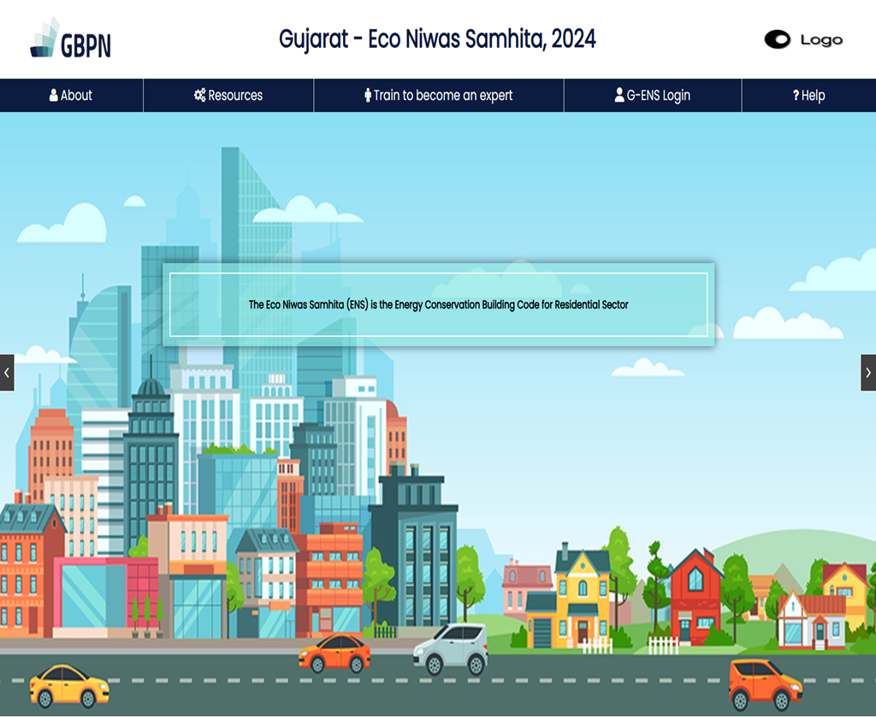
Figure 1: Home Page

Signing Up
The signup process involves recording individual user credentials on the website. To create an account, users must provide initial information. Click on the user icon located on the header section on home page (figure 1), user login form will be displayed, click on the signup text link located at the bottom of the form (figure 3).
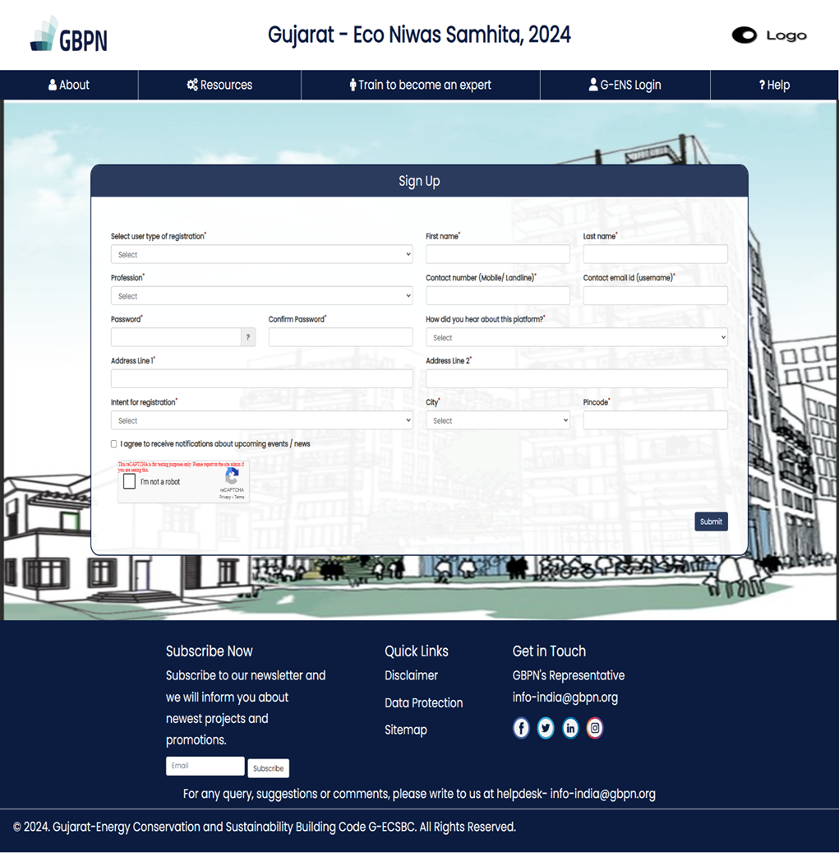
14
13
12
11
10
9
8
7
6
5
4
3
2
1
Figure 2: Sign-Up level
- User Type of Registration: Select type of user. Example – Building Owner.
- First Name: Enter the first name of the user.
- Last Name: Enter the last name of the user.
- Profession: Enter profession of the user. Example – Architect, etc.
- Contact Number: Enter contact number of the user.
- Contact Email: Enter the Email ID. This will be used at the time of login. For example: let’s take “xxxx@gmail.com” as e-mail.
- Password: Enter password. For Example: Xx1#wxyz.
- Confirm Password: Re-enter password to confirm.
- How did you hear about this platform: Enter the source from where you heard about this platform.
- Address Line 1: Enter first line of address.
- Address Line 2: Enter second line of address.
- Intent for Registration: Choose the reason for which user has registered with this tool.
- City: Choose city from the list of cities in Gujrat.
- Pin code: Enter 6-digit pin code according to the address.
Note: In case of successful registration, a verification link shall be sent to the registered email ID. The user is required to click the link in the registration e-mail received for activation of the account.

Signing In
At this level, the user is required to enter the registered email ID and password to login.
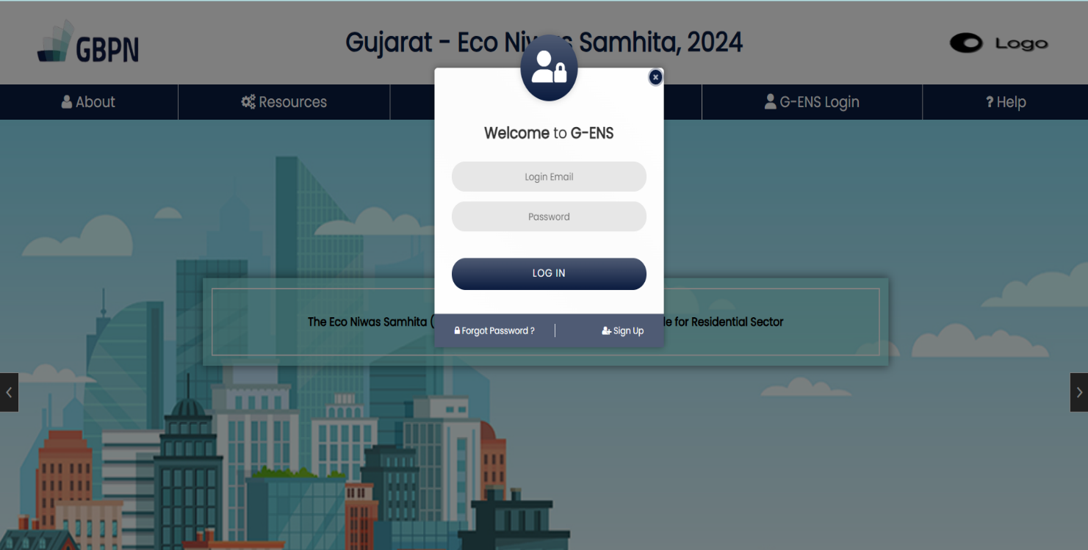
3
2
1
Figure 3: Sign-In level
- Email ID: Enter the email ID used at the time of sign-up here.
For example: Let’s take example email as “giz@yahoo.com” here.
- Password: Enter the registered password at the time of sign-up here.
For Example: put “Aa1@xyza” here.
- Log In: After filling in the required information, press the Log In button. This shall take you to the project listing page of the tool.

Forgot Password
In case the user forgets the registered password, there is a provision to reset the password in the “Forgot Password” button located at the bottom of login form (figure 3). The user is required to enter the registered email ID where the password information shall be sent.
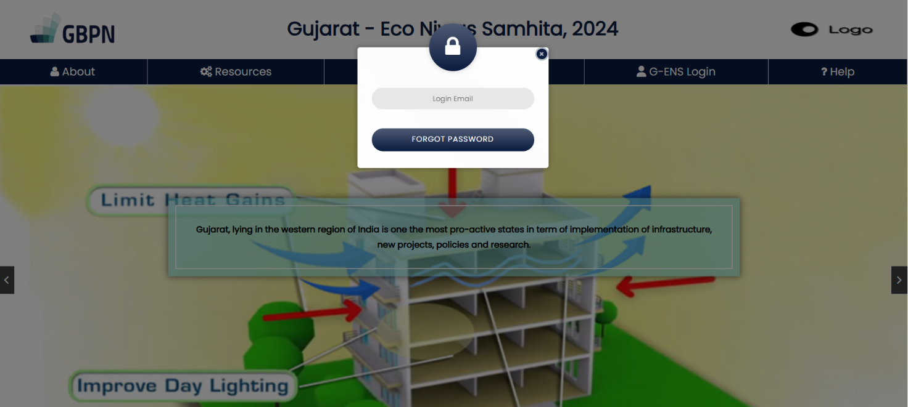
2
1
Figure 4: Forgot Password

- Username: Enter the login email address on which reset code will be sent to user.
- Forgot password: Click on this button so that email will be sent to user with the reset code to change password.
After above form is submitted, a new form will be displayed to the user as shown in figure5.
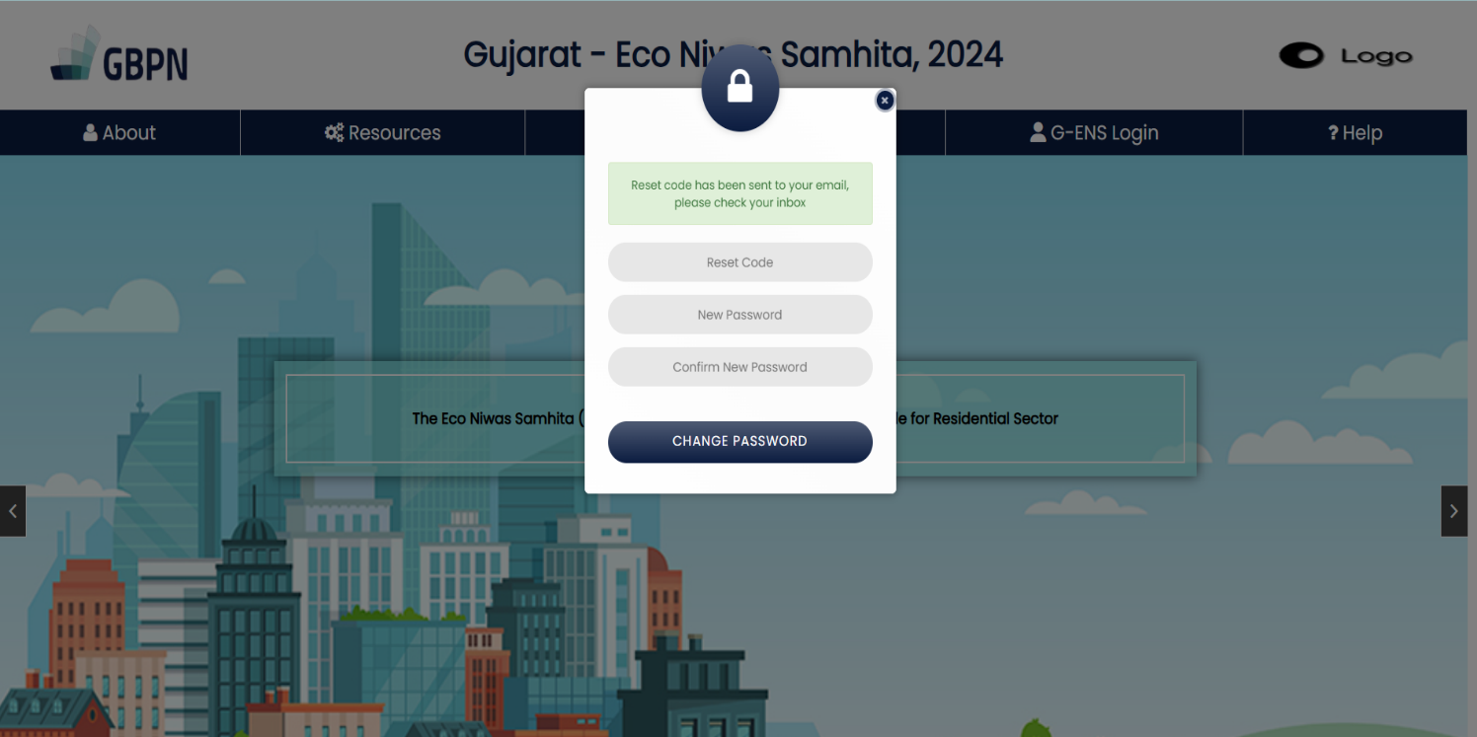
4
3
2
1
Figure 5 : Reset password form
- Reset Code: Enter the code which has been sent to your email.
- New Password: Enter new password.
- Confirm Password: Re-enter password to confirm.
- Change Password: Click on this button to successfully change your password.
Once you have saved your new password, user can attempt to login again with updated credentials. Users will get redirected to dashboard after login is successful.

User Dashboard
This is the user dashboard of the tool where all the projects are listed.
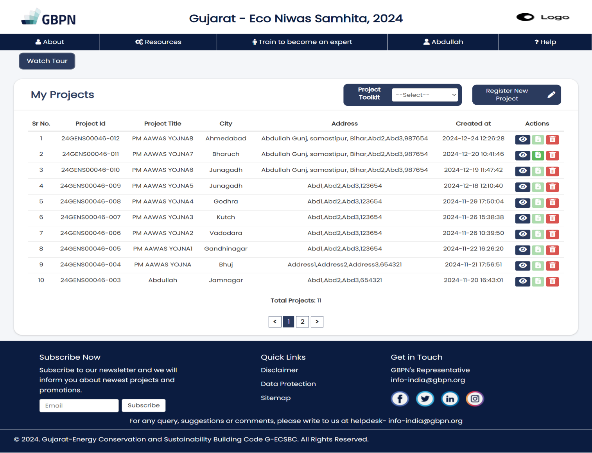
7
6
5
4
3
2
1
Figure 6: User Dashboard
- Watch Tour: The Watch Tour will guide users on how to access the dashboard and provide a detailed explanation of each action, including its purpose and how to perform it effectively.
- Project Toolkit: The Project Toolkit provides essential documents required for project registration and compliance.
- Register New Project: Users can create a new project by clicking this button, this will open a form for the new project entry.
- View: Click on button to open a project and view it.
- Download Compliance Report: Clicking this button allows users to download their compliance report or certificate.
- Delete Project: Clicking this button allows users to delete their entire project with a single click.
- Username: This icon indicates that the user is currently logged in and displays the username beside the icon.

Register a new project
After clicking on the “Register New Project” button on ‘User Dashboard’ (figure 6), a form shown in figure 7 will be displayed to register a new project.
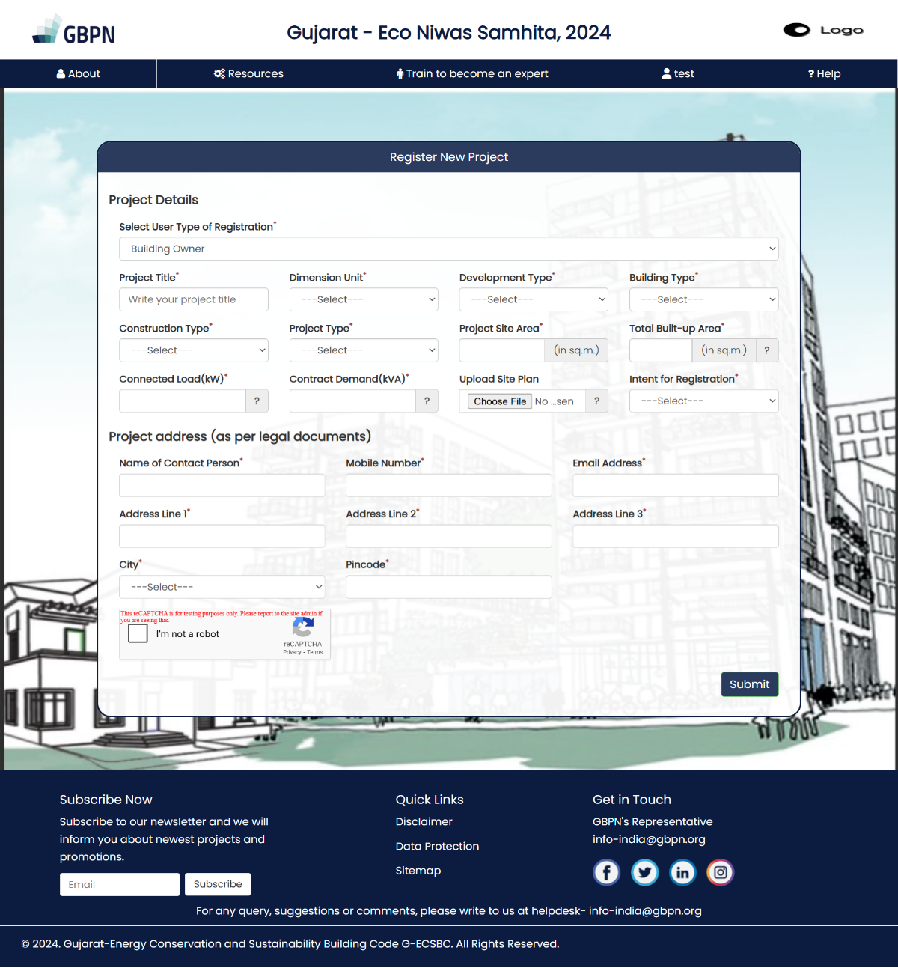
13
11
11
11
10
8
5
6
12
12
9
7
3
2
4
1
Figure 7: Register a new project form
The following fields are described below:
- User Type of Registration: This field is already filled by the user at the time of user registration so this will be pre-filled.
- Project Title: The project name is the name assigned to the project for identification purpose for later use and reference. Please enter a unique name preferably related to design or location of the project.
- Project Site Area: Enter the site area of your project.
- Total Built-Up Area: Built up area is the carpet area plus the thickness outer walls and the area covered by balcony, in m2 for all the blocks in the site. Enter the total built up area of all the blocks, m2
- Connected Load: Already available on the tooltip. Alternative definition: 'connected load' refers to the total sum of the power-consuming ratings of all the electrical equipment connected to a distribution system, regardless of whether they are in operation or not. Information is available in Request letter to DISCOM for load sanctioning/ Electrical DBR
- Contract Demand: Contract demand is the amount of electric power that a customer demands from utility in a specified interval (Unit used is kVA). Information available in Request letter to DISCOM for load sanctioning/ Electrical DBR
- Site Plan: Upload site plan of your project to help us better understand.
- Name of Contact Person: Enter the name of contact person for the project.
- Mobile Number: Enter contact number.
- Email: Enter the email address of contact person.
- Address: Enter project address in address line 1,2,3.
- City and Pin code: This field represents the city in which the project is located. Based on the selection of the state, the corresponding city list shall be available in the drop down. Please select the city where the project is being developed from the drop-down list. Enter the appropriate pin code as well.
- Submit: Click on this button to submit the form. Users will automatically get redirected to the main ECSBC tool.

Project Details Page
Our tool contains three levels in which user must provide information – Project, Block and Certificate level. Here is the first level – Project Level.

Project Level Information
The first level that gets opened is project level information which has two sections – Project Details and Block List.
User must first fill project details such as Total no of residential blocks, covered area of all blocks, amenities area. Few of the fields are already pre-filled based on data previously entered.
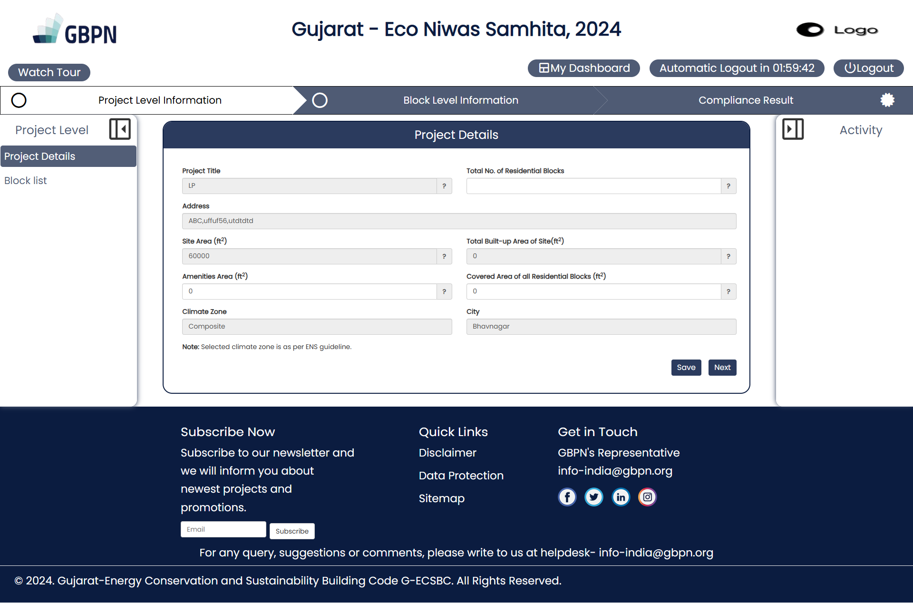
5
8
7
6
3
4
2
1
Figure 8 : Project Details form

- Watch Tour: The Watch Tour button displays step-by-step guidance for filling out the Project Details form when the Project Details tab is active.
- Project Details Tab: The Project Details tab displays a form for entering the project details information.
- Total No. of Residential Blocks: Enter total number of residential blocks tested for compliance
- Amenities Area: Amenity Area means areas intended for use for aesthetic or recreational purposes within the boundaries of a lot. It may include landscaped open space areas, patios, shared lounges, swimming pools, recreation facilities. Amenity areas are not to include driveways or parking areas
- Covered Area of all Residential Blocks: The covered area includes all spaces under a roof within the property's boundaries, including both living spaces and other spaces like balconies or corridors. It does not include open spaces
- My Dashboard: Clicking on "My Dashboard" button will redirect the user to their dashboard.
- Automatic Logout: The Automatic Logout label continuously displays a countdown timer, indicating the remaining time before automatic logout. This timer resets whenever the user performs an action, such as saving a form.
To prevent data loss, users can easily monitor the time left to save their progress. Additionally, an alert message appears when 10 and 5 minutes remain before logout, notifying the user to save their data. If the user saves any data, the timer resets and restarts from zero.
- Logout: The Logout button allows the user to securely log out of their account.
Note: Site Area is always greater than or equal to the sum of covered area and amenities area.

When the page reloads, user reaches category details tab. The form as shown in figure 9 is to add a single representative block or building to a project. Users can add multiple representative blocks to a project by following the steps given below.
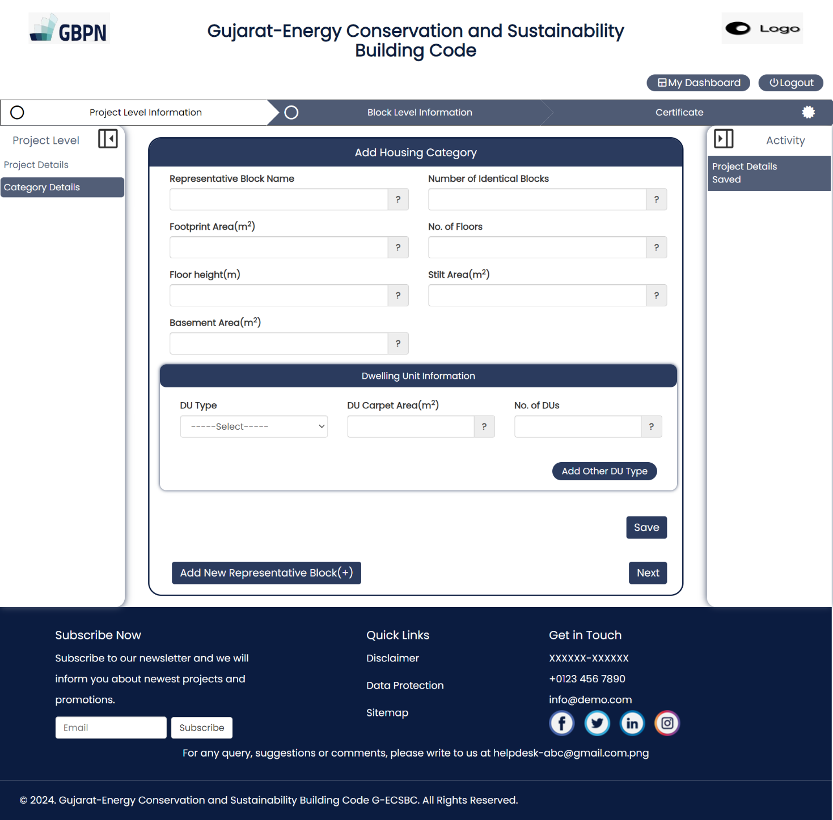
13
12
11
10
9
8
7
6
5
4
3
2
1
Figure 9 : Category details form
The form contains following entries:
- Representative Block Name: Unique name for a representative block whose properties are identical to a certain number of residential blocks.
- Number of Identical Blocks: This indicates a number of blocks that are identical on the project site.
- Footprint Area: The footprint area of a building represents the total surface area that the building covers on the ground level, including any protrusions such as balconies or overhangs.
- No. of floors: Enter the number of floors in the building.
- Floor Height: Enter floor height in metres for a single floor.
- Stilt Area: The stilt area in a building typically refers to the space between the ground level and the first inhabited floor. It's often used for parking, storage, or recreational purposes.
- Basement Area: The basement area in a building refers to the floor(s) constructed below the ground level.
Dwelling unit information: Provide details about the individual living spaces within a residential development. You can add multiple DU types.
- DU Type: Choose DU Type from 1/2/3/4 BHK.
- DU Carpet Area: Enter carpet area of related single DU unit.
- Number of Dus: Enter number of units of this type.
- Add Other DU Type: Click on this button in case user wants to add more than one du type. Once clicked DU type, carpet area and number of Dus form fields will be repeated as shown in figure 10.
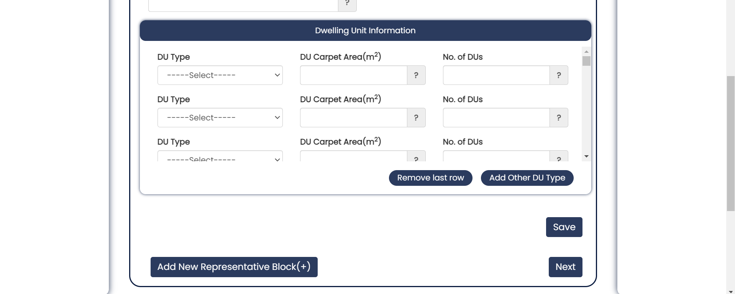
Figure 10 : Add other DU type when adding dwelling unit information
- Save: Click on this button to save this representative block. Make sure to fill all the fields correctly. User is required to save this form before creating a new block. After a block is saved, new block created will be listed under category details tab in navigation view. See figure 11 for reference.
Note: Housing category will be auto calculated for each representative block from the information you have entered. Users will see block names listed in navigation view under housing category on the left-hand side of the form as soon as they are saved.
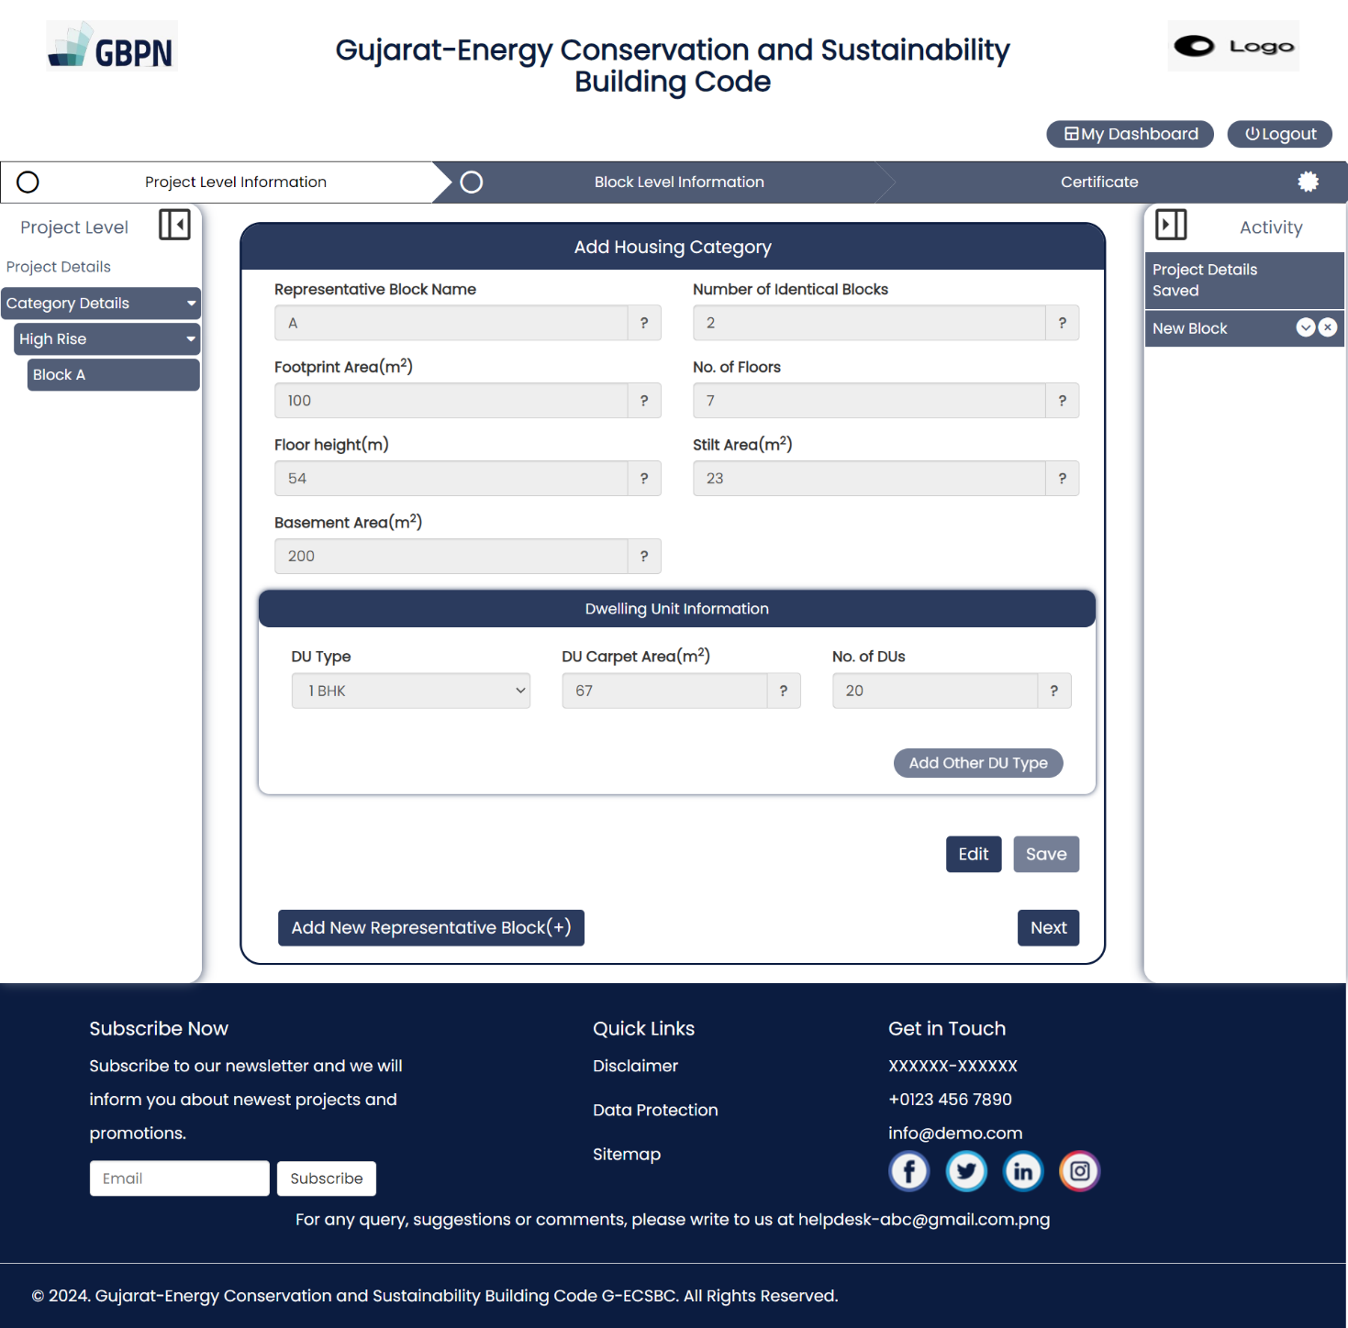
Figure 11 : Show representative blocks in navigation view
- Add New Representative block: Click on this button to add a new representative block. A new form will be displayed to the user. See figure 12 for reference. User can follow the same steps to fill this form and add a new block to a project.
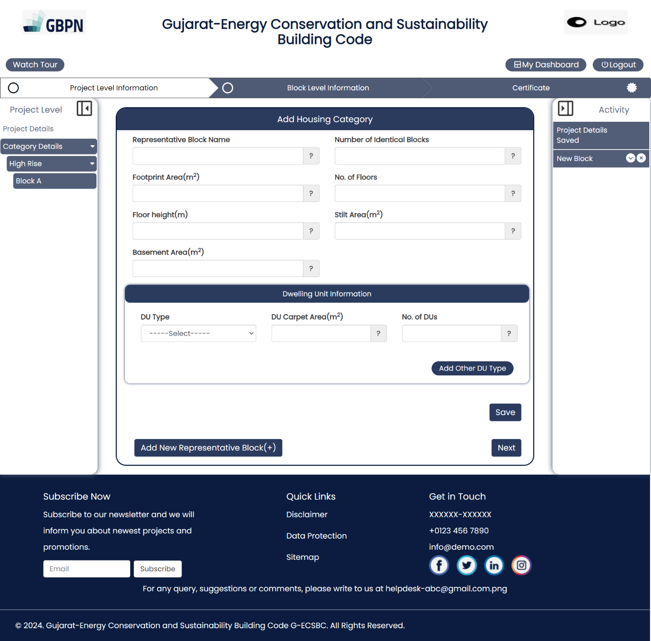
Figure 12 : Add a new block to a project
To reach block level, user needs to click on ‘Next’ button. If the sum of all identical blocks is not equal to total residential blocks, i.e., all of them are not registered, then following message will pop up.
User can also edit or delete the block created from activity panel at right-hand side of the screen.
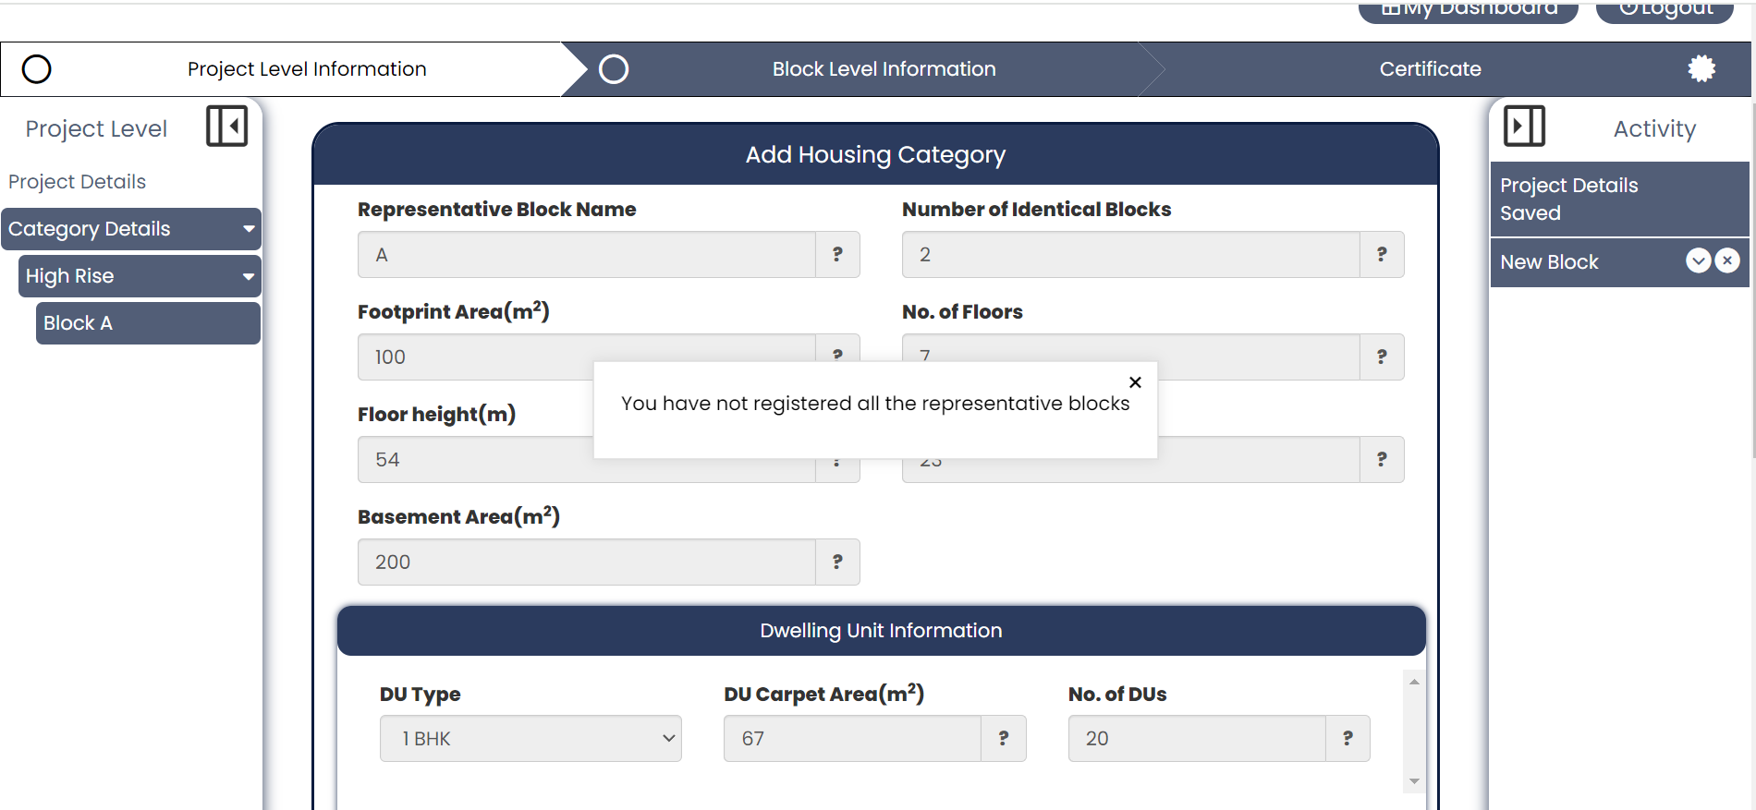
Figure 13 : Validation check when moving to block level
If all are registered then, tool moves on to block level information and following page will be seen as shown in figure 14.
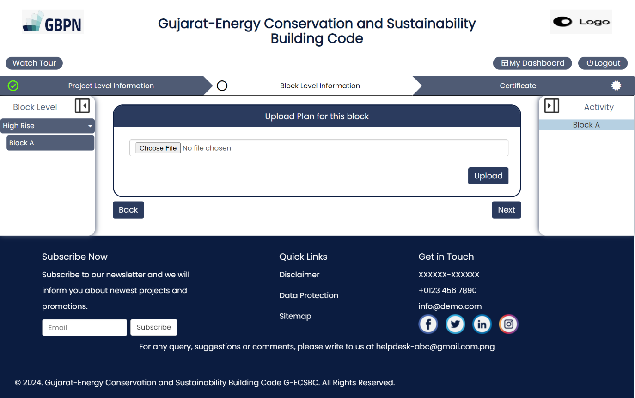
Figure 14 : Move to block level information

Block Level Information
User needs to import block plan file (image/pdf) to form (for example- figure 14) and click on ‘Upload’ button. Once file is uploaded following canvas will get displayed to the user with the uploaded image file of the block, now the user can start adding items to it.
The block canvas displays the uploaded block plan
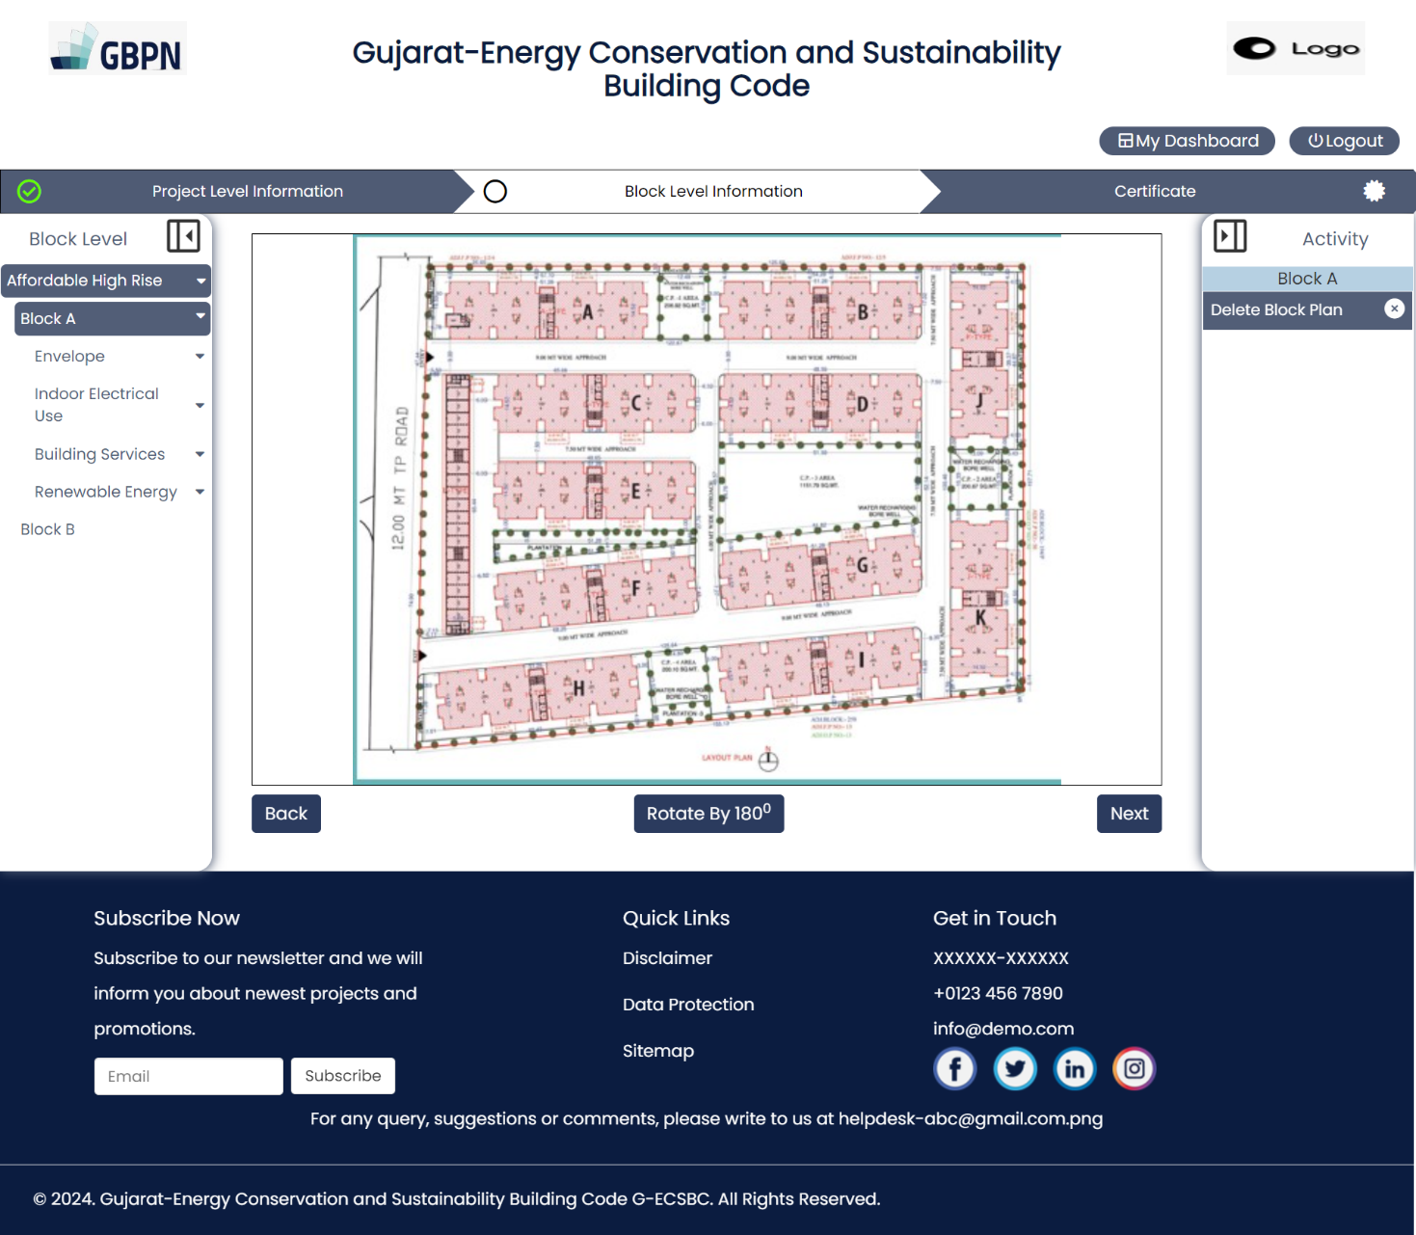
Figure 15 : Uploaded block plan will be shown on canvas
Users can modify the block plan uploaded by clicking on the 'Delete Block Plan' button located on the activity panel on the right-hand side of the screen. Following this action, users should proceed with the same steps they followed initially to upload new file.
In case the user needs to rotate the image by 180 degrees, then by clicking on ‘Rotate by 180⁰’ this can be done.
Similarly, upload block plan for all representative blocks.

Building Envelope
Ensure regulatory compliance by meticulously assessing the safety standards and structural integrity of walls within residential buildings.
Wall:
Initiate the process by selecting a wall type from the navigation view, offering two convenient options:
- Choose from a comprehensive list of pre-defined wall types.
- Alternatively, craft your own customized wall type and seamlessly integrate it into the navigation view. Follow these streamlined steps:
  - Navigate to the 'Custom Wall' tab located at the bottom of the walls listed within the Wall dropdown menu.
  - Upon selection, a form will prompt you to input a unique wall name (exclusive to your project) and select a method – either 'By Layers' or 'By Properties'.
  - Opting for the 'By Layers' method, specify the number of layers and proceed to add layer materials – whether predefined or custom (providing a custom name where applicable) – along with layer thickness (in millimeters) and conductivity (if custom material is chosen).
  - The U-value of the wall will be automatically computed based on the provided information.
  - Alternatively, if selecting the 'Properties' method, simply input the U-value (up to two decimal places) in the designated field.
  - Click on the 'Save' button to preserve your input. Upon page refresh, your custom wall will be listed under predefined walls into every block of your project.
- Effortlessly drag and drop your chosen wall from the navigation onto a designated direction (West/North/South/East) on the canvas, prompting a wall parameter form to appear.
- Input the wall length in meters from the current direction, and if user wants to apply the same wall type to additional directions, toggle the 'Apply Material to Other Facade' dropdown to 'Yes'.
- Select the checkboxes corresponding to the other facade directions where you wish to apply the same wall type.
- Input the wall lengths (in meters) for the other facade directions and click on 'Save'.
- Congratulations! The wall has now been successfully integrated into the selected directions.
For help, refer to the accompanying images below.
Drag and drop any wall type onto a direction on the canvas to trigger a form display.

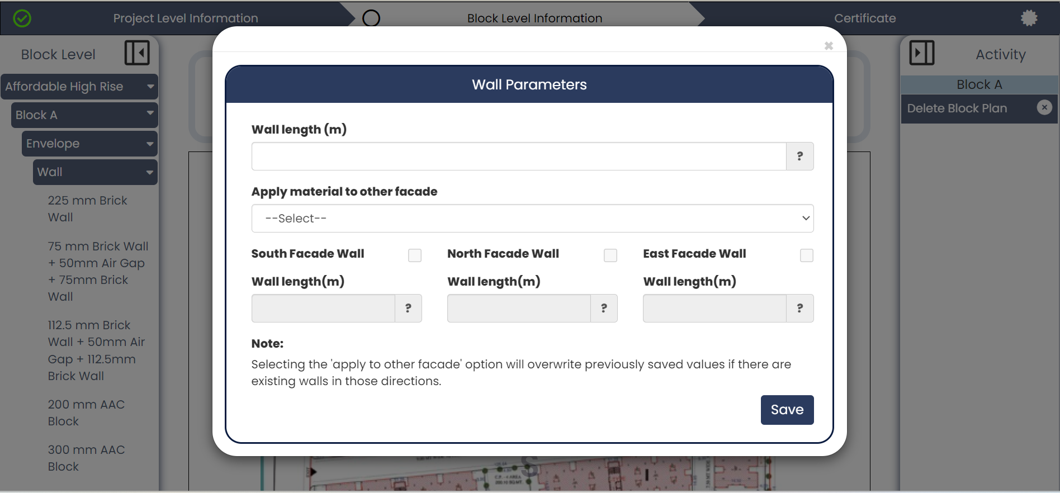
Figure 16 : Form to add wall material type in directions for a block
Click on this item to open a form for creating a custom wall type

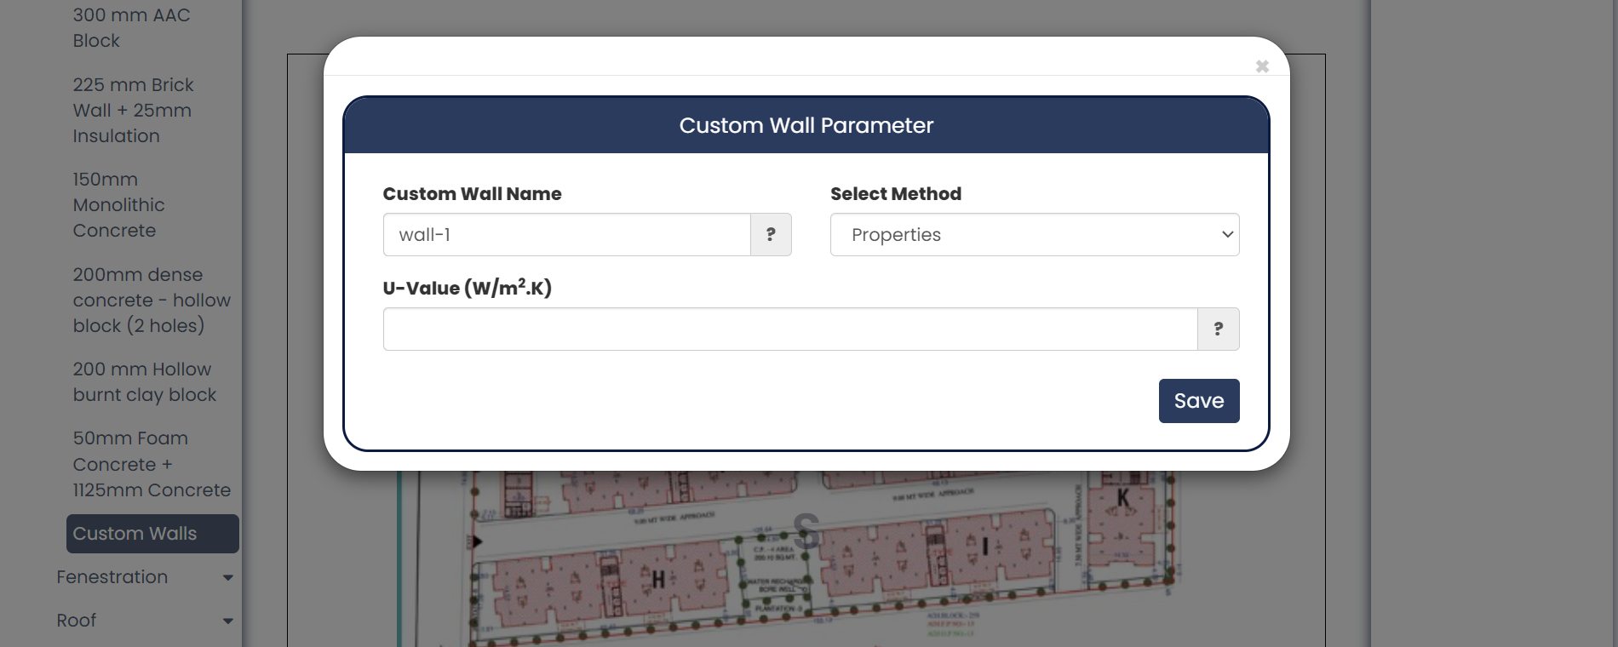
Figure 17 : Create custom wall type using properties method

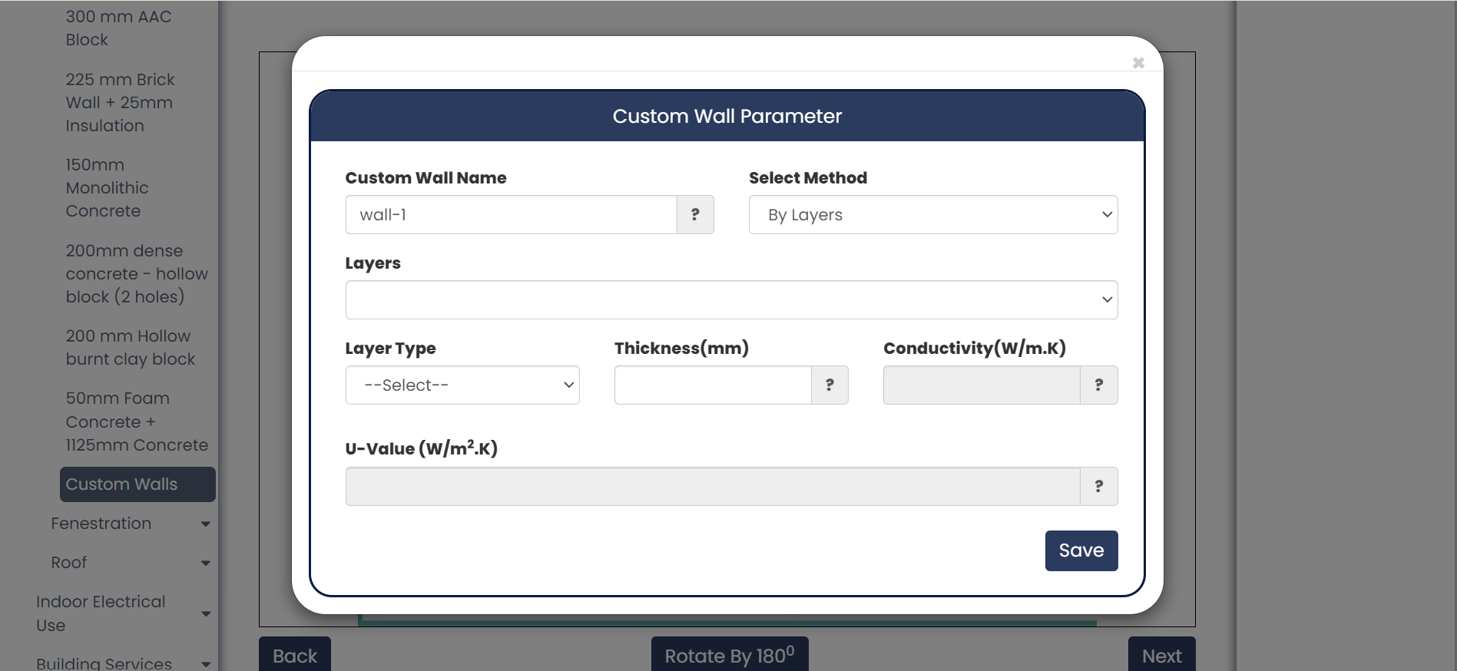
Figure 18 : Create custom wall type using layers method
Once walls have been seamlessly integrated into all directions for a block, proceed to the next step of adding fenestrations to the building.
Fenestration – Window:
To include windows in your block, start by crafting your window type. Click on 'Add Window', prompting a form to appear. After a new window is created, users can proceed to add window to any direction on block canvas.
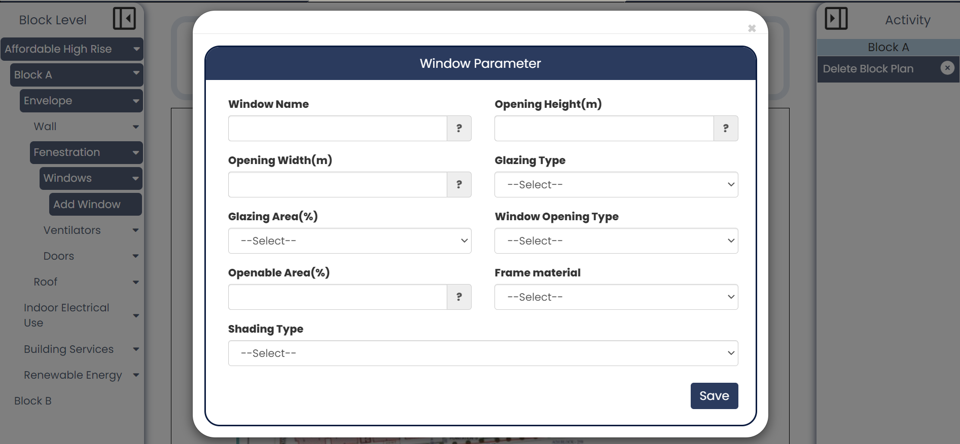
Figure 19 : Add custom window type for a project
Window form contains following entries:
- Window Name: Enter a unique window name that represents the new window type added to the project.
- Opening Height: The opening height of a window refers to the vertical dimension of the window opening.
- Opening Width: The opening height of a window refers to the vertical dimension of the window opening.
- Glazing Type: The glazing type of a window refers to the kind and arrangement of glass panes within the window.
- Glazing Area: The glazing area of a window refers to the surface area of the glass.
- Window Opening Type: Select the opening type of the window.
- Openable Area: The openable area of a window refers to the portion of the window that can be opened to allow ventilation.
- Frame Material: Select material used to construct the frame of the window.
- Shading Type: Select the type of shading used to diffuse sunlight.
When form is saved, upon refreshing the page, the newly created window will be visible under Envelope > Fenestration > Window, as shown in below figure.
Drag and drop the custom window created onto the canvas in any direction to display popup form
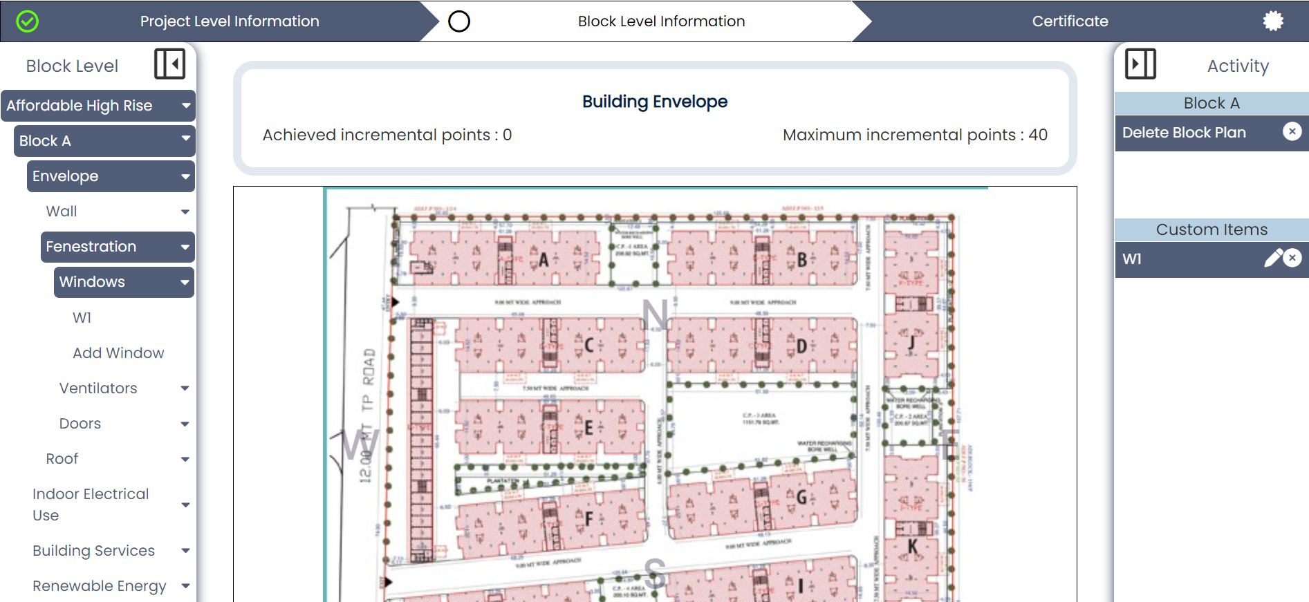
Figure 20 : Created window will be seen in navigation view under Windows dropdown.
Below form will show as popup
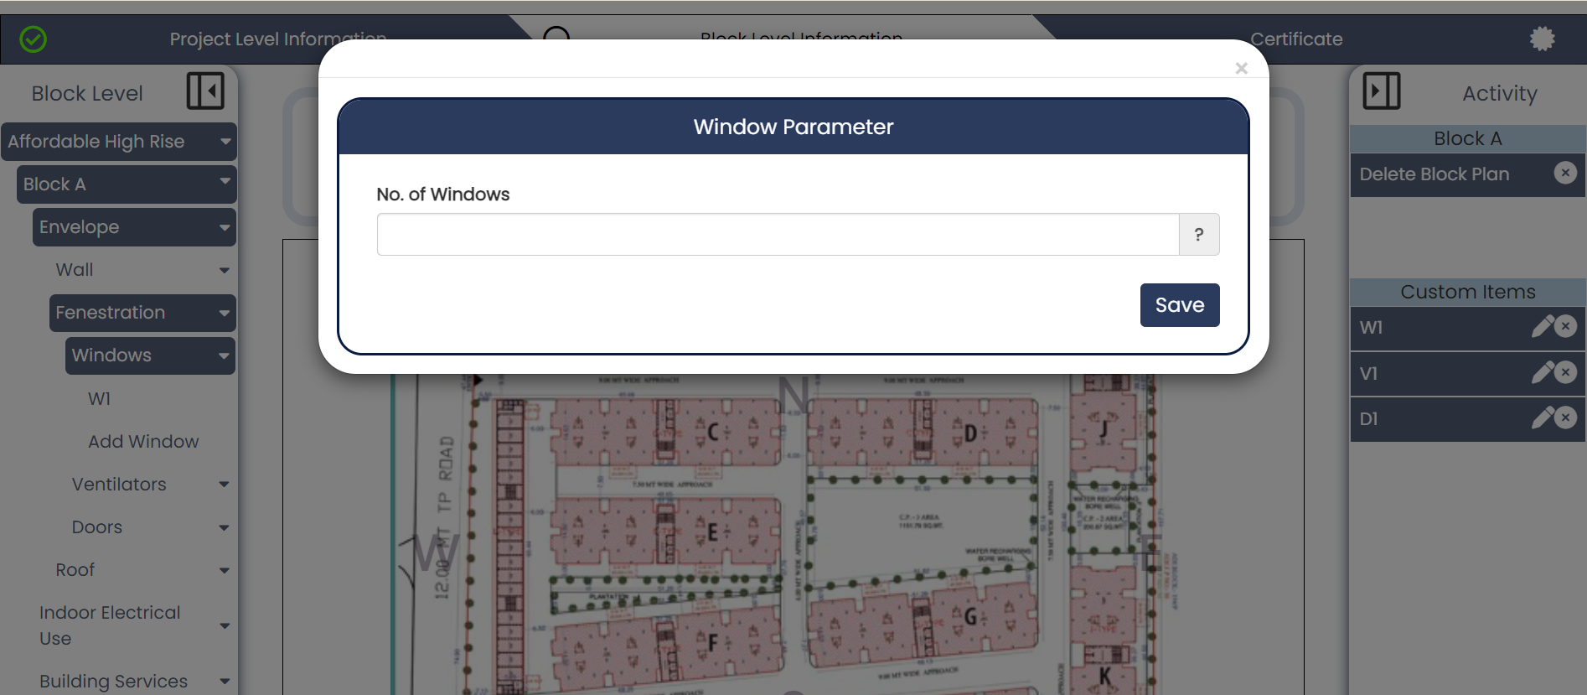
Figure 21 : form when adding windows to a block
Specify the number of windows for that type in the dropped direction and save the form. Your window will now be listed in the activity panel, allowing users to edit or delete it from there.
Fenestration – Ventilator:
To incorporate ventilators into your block, begin by crafting your ventilator type. Click on 'Add Ventilator', triggering the appearance of a form. Fill out the fields, assign a unique ventilator name, and then save your entry.
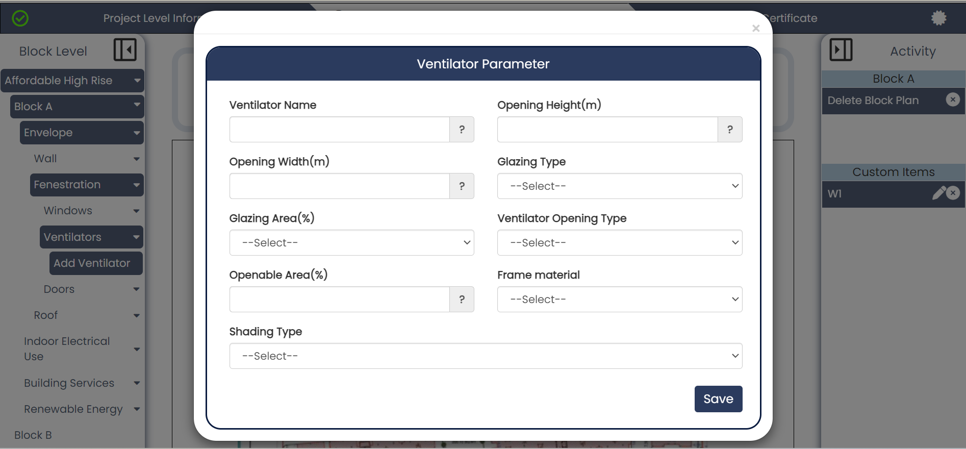
Click on this item to trigger a popup form.
Figure 22 : Create custom ventilator type for project
Ventilator form contains following entries:
- Ventilator Name: Enter a unique ventilator name that represents the new ventilator type added to the project.
- Opening Height: Enter the opening height of a ventilator typically refers to the distance or measurement from the bottom edge of the ventilator to its fully open position.
- Opening Width: Enter the opening width of a ventilator typically refers to the width of the aperture or the space through which air can flow when the ventilator is open.
- Glazing Type: Select the glazing type of a ventilator refers to the material used for the window or glass pane within the ventilator assembly.
- Glazing Area: The glazing area of a ventilator refers to the total surface area covered by glass or any transparent material in the ventilator structure.
- Ventilator Opening Type: Select the ventilator opening type of a ventilator refers to the mechanism by which air is allowed to flow.
- Openable Area: Enter opening area of a ventilator which refers to the total area through which air can flow into or out of the ventilator system.
- Frame Material: Select material used to construct the frame of the ventilator.
- Shading Type: Select the type of shading used to block light.
After refreshing the page, your newly created ventilator will appear under Envelope > Ventilation > Ventilator as shown in below figure.

Proceed to add ventilator to the block canvas by drag and drop feature.
Drag and drop it onto a direction on canvas
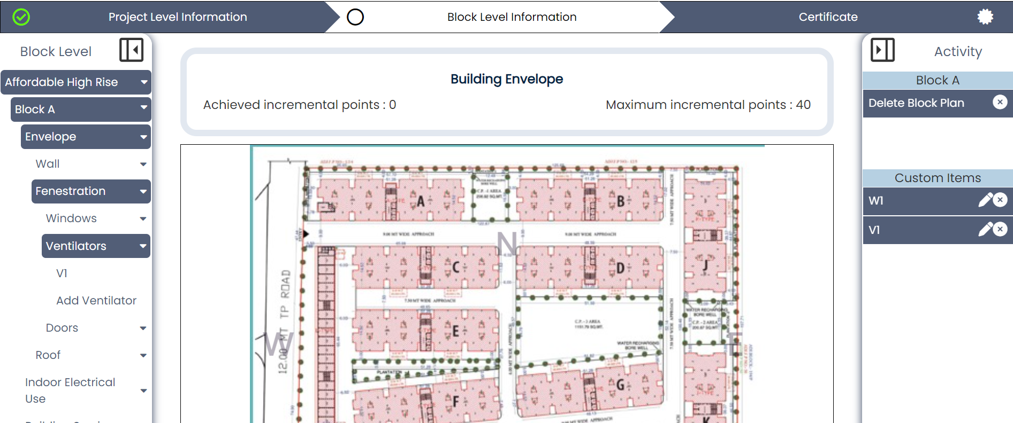
Figure 23 : Ventilator types created will be listed under ’Ventilators’ dropdown in navigation panel
Next, drag the ventilator from the navigation and release it onto a direction on the canvas. Below form will be shown as popup.
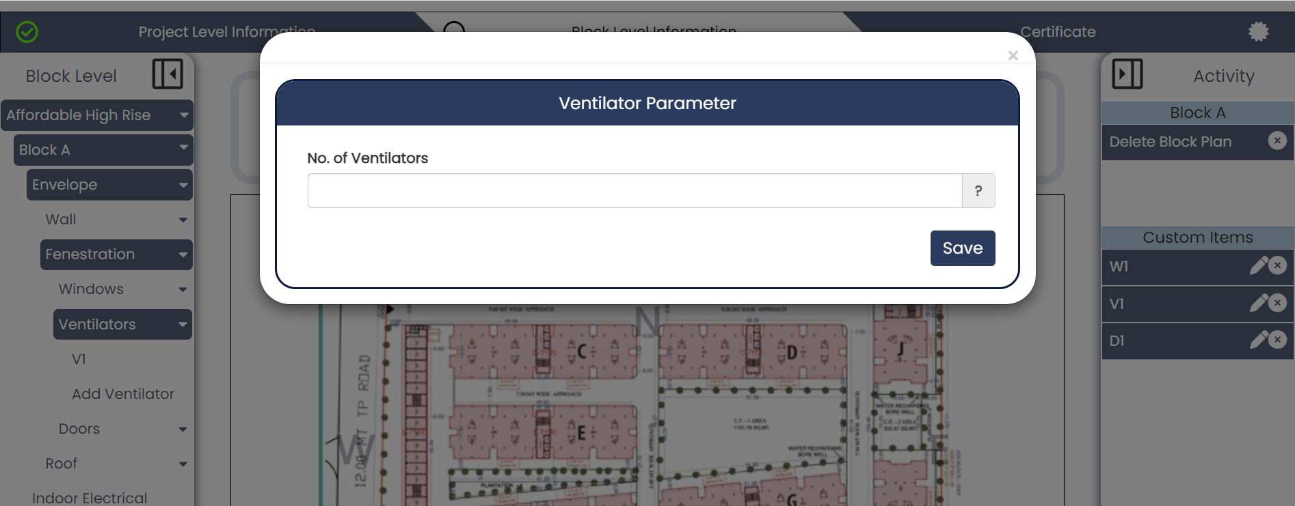
Figure 24 : form to be filled when adding ventilator to block
Specify the number of ventilators for that type in the dropped direction and save the form. Your ventilator will now be listed in the activity panel, enabling users to edit or delete it from there.
Fenestration – Door:
To incorporate doors into your block, begin by creating your door type. Click on 'Add Door', triggering a form to appear. Fill out the fields, giving your door a unique name, and then click 'Save'.
Click on this item to display form for adding a new custom door type

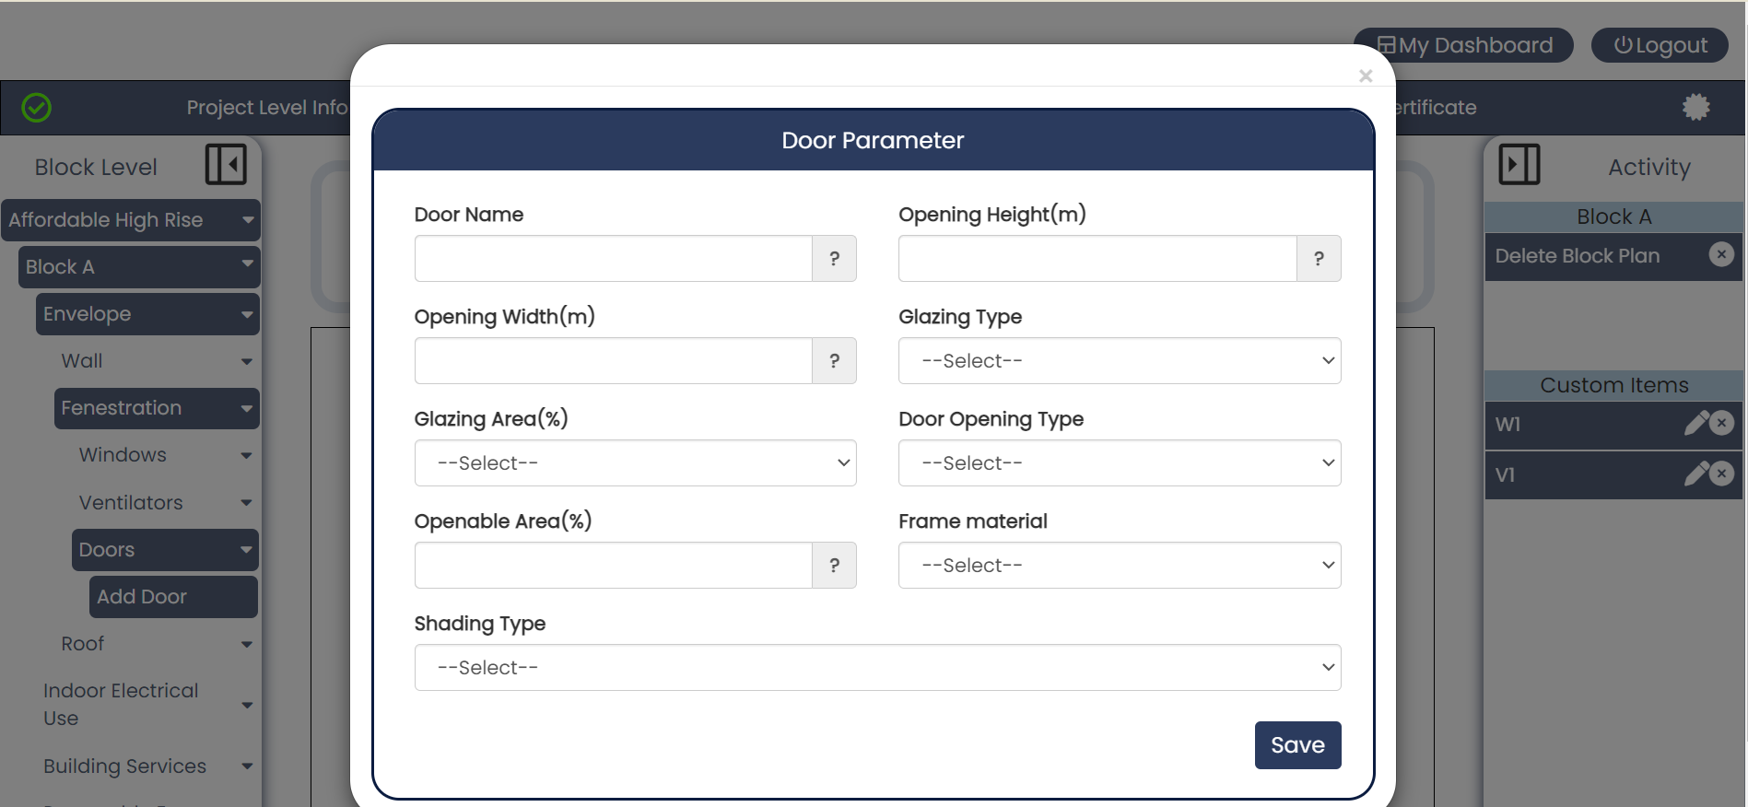
Figure 25 : Create custom door type for project
After refreshing the page, the newly added door will appear under Envelope > Fenestration > Door.
- Door Name: Enter a unique door name that represents a new door type added to the project.
- Opening Height: Enter the opening height of a door which refers to the vertical measurement from the floor to the topmost point of the door frame when the door is fully open.
- Opening Width: Enter measurement of the width of the space into which the door will fit.
- Glazing Type: Select glazing type of a door which refers to the specific kind of glass or transparent material used within the door.
- Glazing Area: The glazing area of a door refers to the portion of the door that is made of glass or other transparent or translucent material.
- Door Opening Type: The opening type of a door refers to the way a door operates and swings open or closed.
- Openable Area: The openable area of a door refers to the portion of the door that can be moved or opened to allow passage.
- Frame material: The frame material of a door refers to the substance used to construct the door's frame, which supports and encloses the door.
- Shading Type: Select shading type of a door that refers to the method or material used to control the amount of light and visibility through the door.
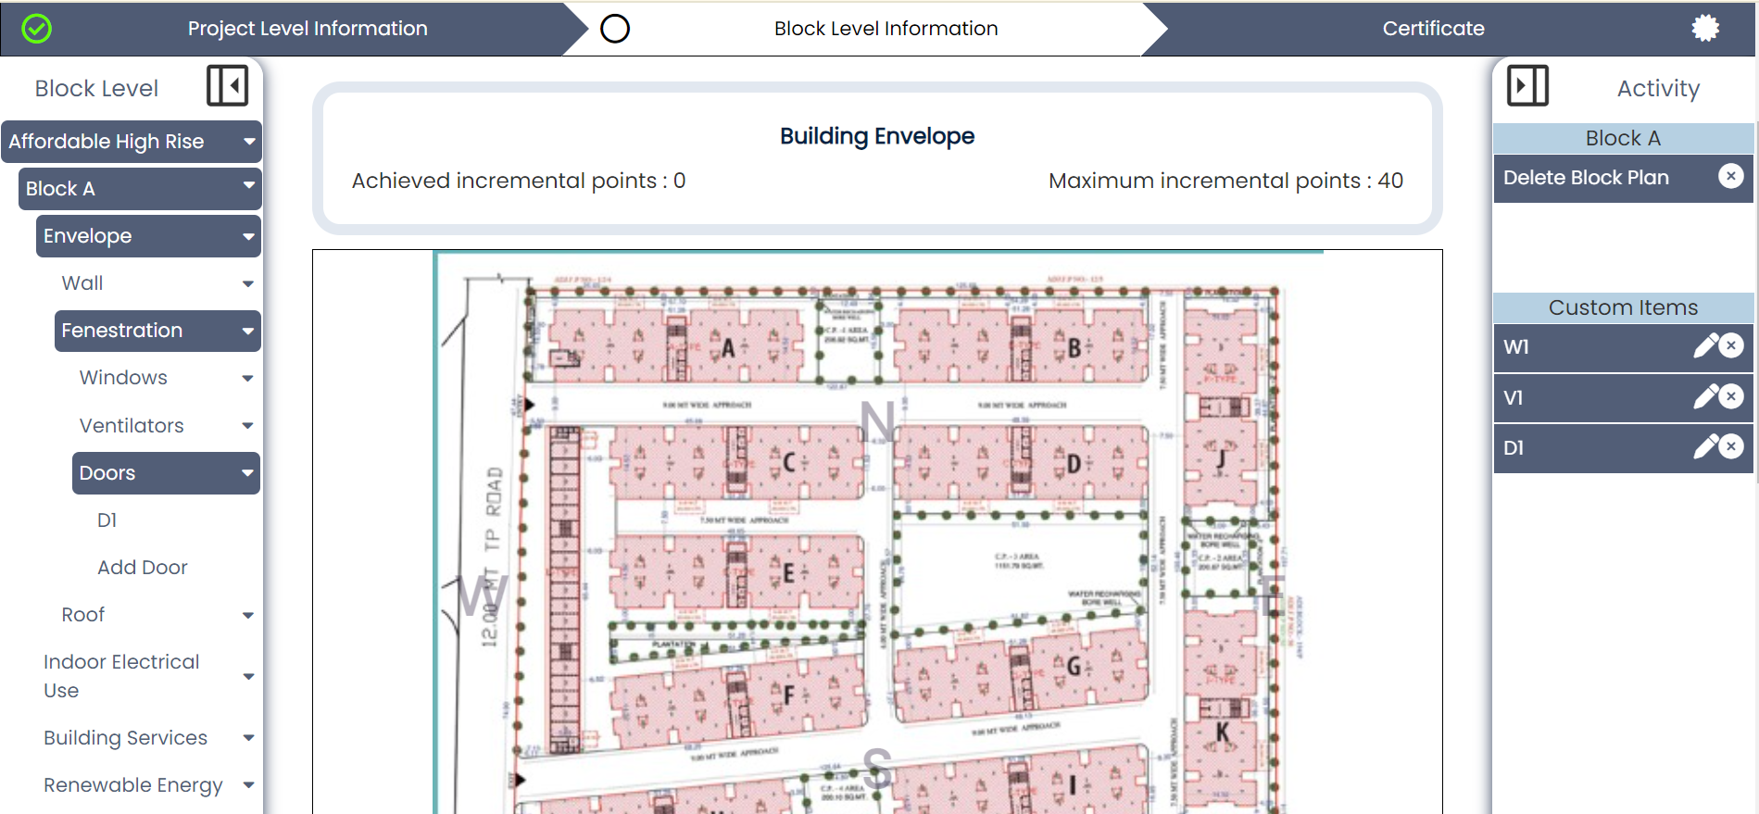
Drag and drop it onto a direction in canvas

Figure 26 : Created door types will be listed under ‘Doors’ dropdown of navigation panel
Drag the door from the navigation and drop it onto a direction on the canvas.
Specify the number of doors for that type in the dropped direction and save the form. Your door will now be listed in the activity panel, enabling users to edit or delete it from there.
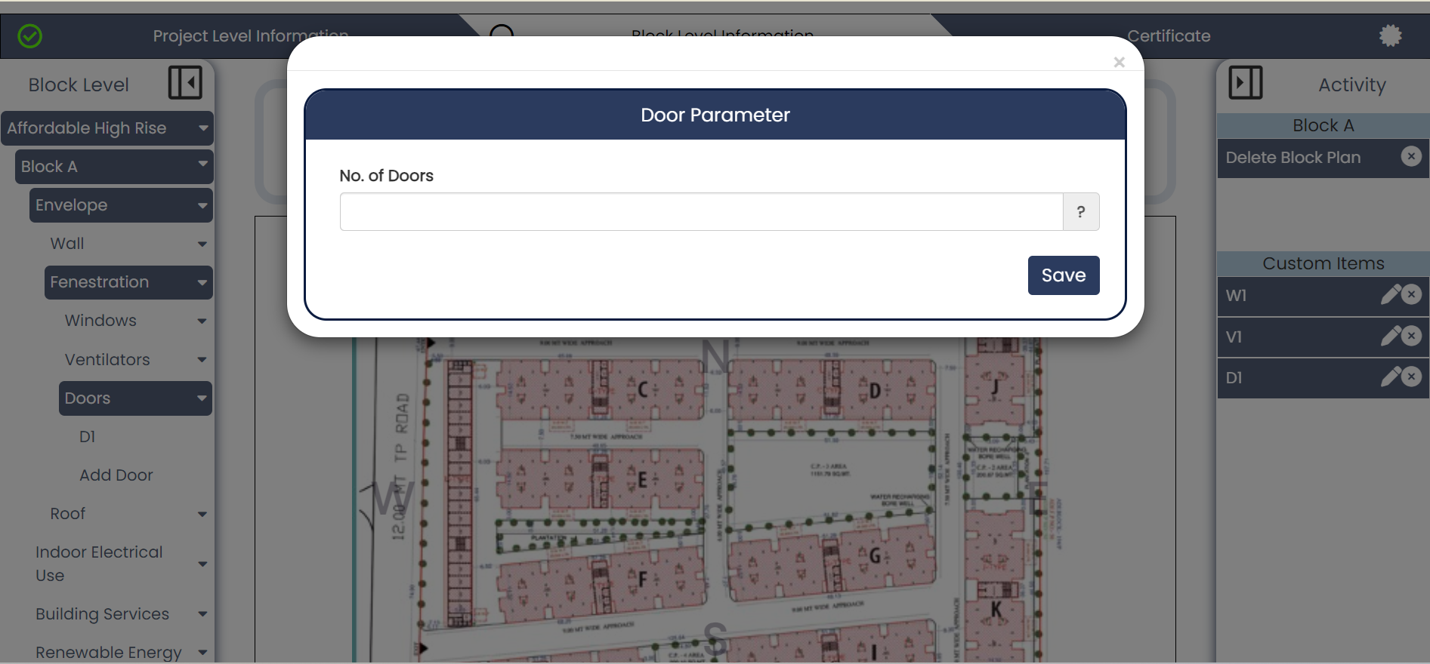
Figure 27 : Form to fill when adding door type to a block
Roof:
Ensure compliance with regulations by thoroughly evaluating the safety standards and structural integrity of roofs within residential buildings.
Commence by accessing a roof type from the navigation view, which provides two convenient avenues:
- Select from a comprehensive list of pre-defined roof types.
- Alternatively, create your customized roof type and seamlessly integrate it into the navigation view. Follow these streamlined steps:
  - Navigate to the 'Custom Roof' tab located at the bottom of the roofs listed within the Roof dropdown menu.
  - Upon clicking, a form will prompt you to input a unique roof name (exclusive to your project) and choose a method – either 'By Layers' or 'By Properties'.
  - If opted for the 'By Layers' method, specify the number of layers, and proceed to add layer materials – whether predefined or custom (providing a custom name where applicable) – along with layer thickness (in millimeters) and conductivity (if a custom material is chosen).
  - The U-value of the roof will be automatically computed based on the provided information.
  - Alternatively, if selecting the 'Properties' method, simply input the U-value (up to two decimal places) in the designated field.
  - Click 'Save' to preserve your input. Upon page refresh, your custom roof will seamlessly integrate into every block of your project.
- Effortlessly drag and drop your selected roof from the navigation onto canvas, triggering a roof parameter form to appear.
- Input the ‘roof area’ input field and click 'Save'. Congratulations, the roof has now been successfully integrated into the selected directions.
For more help, refer to the accompanying images below.
Click on this item to open custom roof form
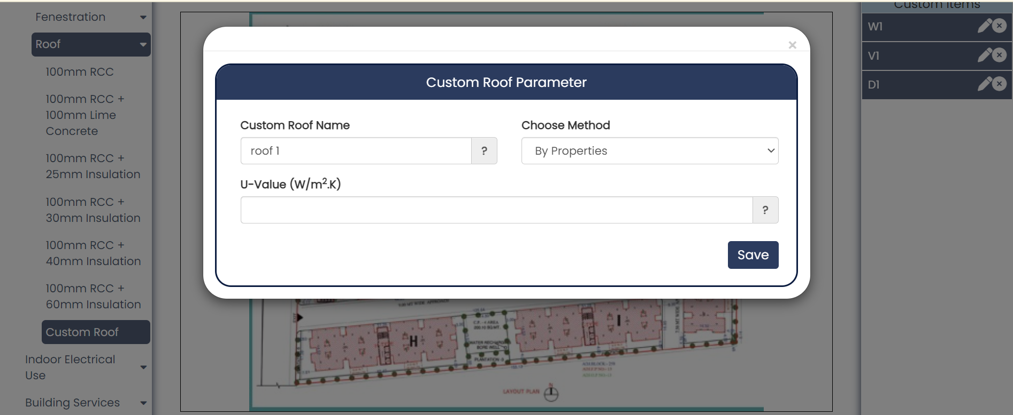
Figure 28 : Create custom roof using properties method

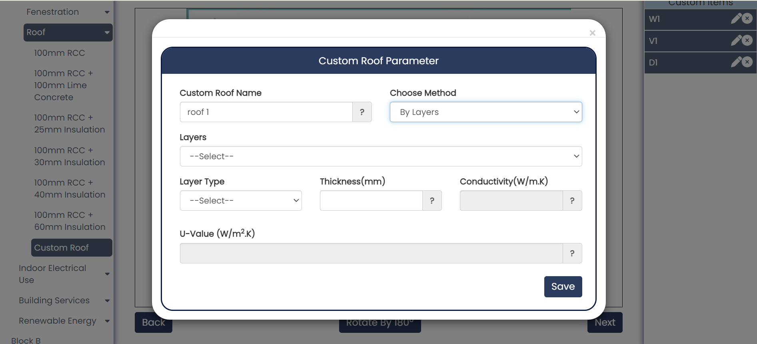
Figure 29 : Create custom roof using layers method
Drag and drop item onto the canvas for adding roof to a block

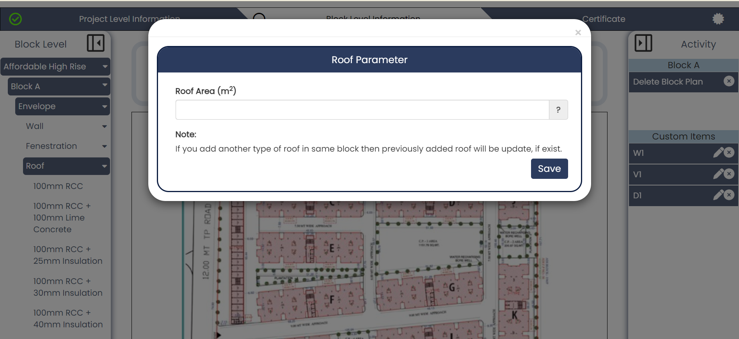
Figure 30 : Form to be filled when adding roof to a block
Once roofs have been seamlessly integrated for a block, proceed to the next step of adding indoor lighting to the building.

Indoor Electrical Use
Indoor Lighting:
Users can add multiple types of indoor lighting installed on their project site by dragging indoor elements (LED Bulb, LED Tube Light, Incandescent Bulb, Decorative Light) from navigation to block canvas. For example, you have selected LED Bulb and once its dopped onto canvas, below form will popup.
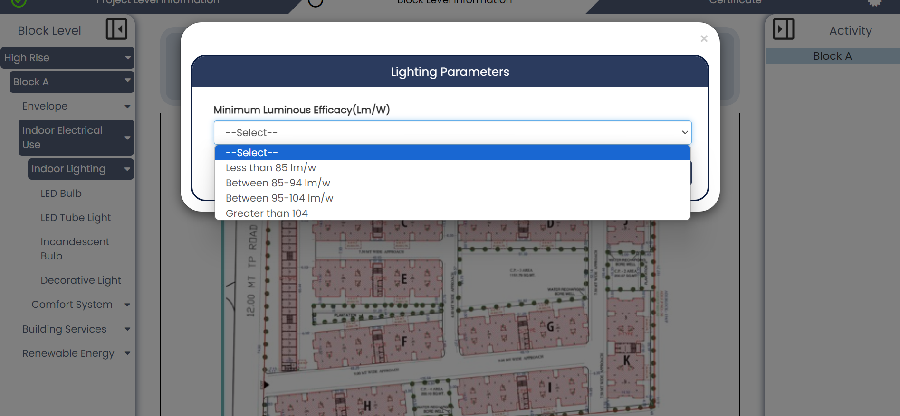
Drag and drop it onto block canvas
1
Figure 31 : Adding indoor lighting to a representative block
    - Minimum luminous efficacy: Select efficacy according to lowest value of the type you have selected. For example, suppose you have installed LEB Bulbs on your site with varying Lm/w values, so you must determine minimum value of them and accordingly select option in form.
Similarly, you can proceed to register more lighting w.r.t block and follow same procedure as above.

Comfort System – Ceiling Fan:
Provide details about types of ceiling fan added to representative block.
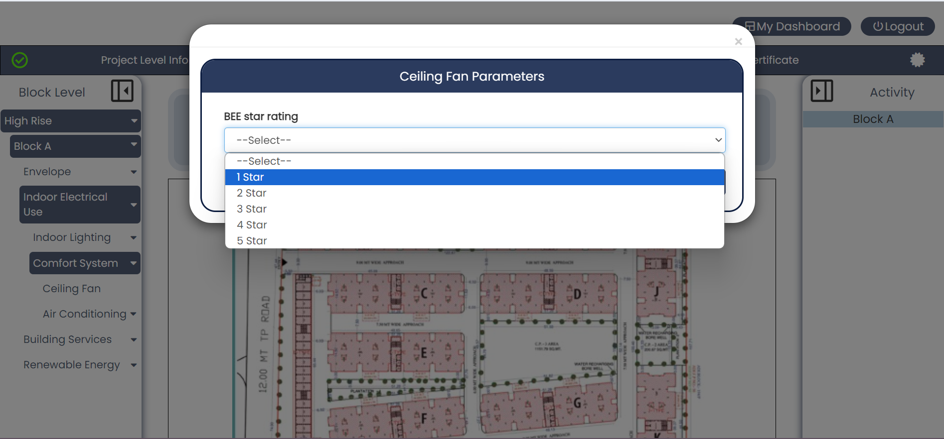
Drag and drop it onto block canvas
1
Figure 32 : Adding ceiling fan to a representative block
- BEE star rating: Similarly choose minimum star type of all ceiling fans installed in the block location.
Comfort System – Air Conditioner:
Drag and drop any air conditioning type onto the block canvas prompting a form to appear.
Drag and drop item onto block canvas

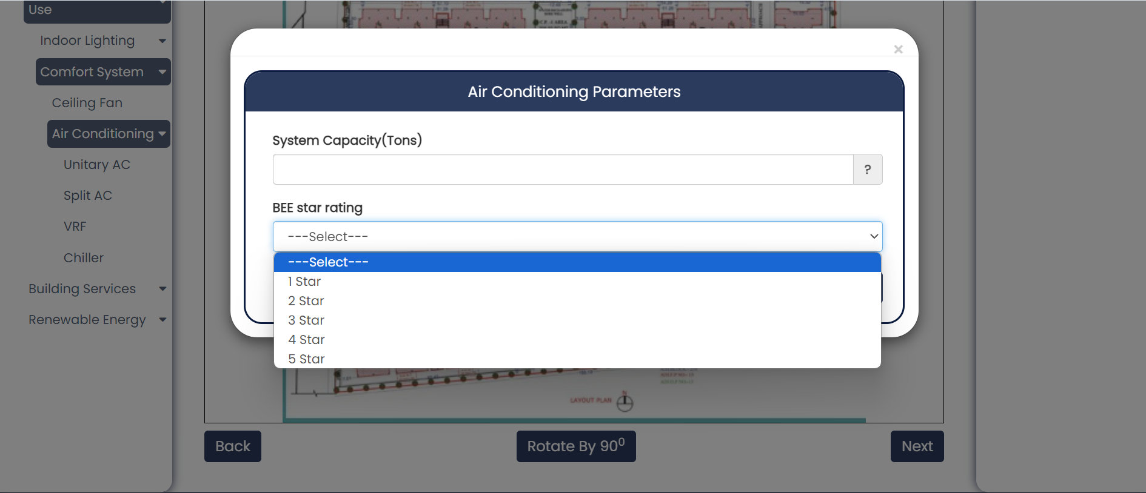
2
1
Figure 33 : Add air conditioner to representative block
- System Capacity: Add minimum capacity installed of selected ac type on your block.
- BEE star rating: Add BEE star rating installed of selected ac type on your block.

Building Services
Building services in residential buildings include various components such as power factor correction systems, electrical systems, pumps for water distribution, and lighting for common areas, all of which contribute to the efficient operation and functionality of the building.
3-Phase Power Factor Correction:
Drag 3 Phase power factor from left hand side navigation view and drop it onto the block canvas. The following form will prompt open as shown in the image below.
Drag and drop item onto block canvas
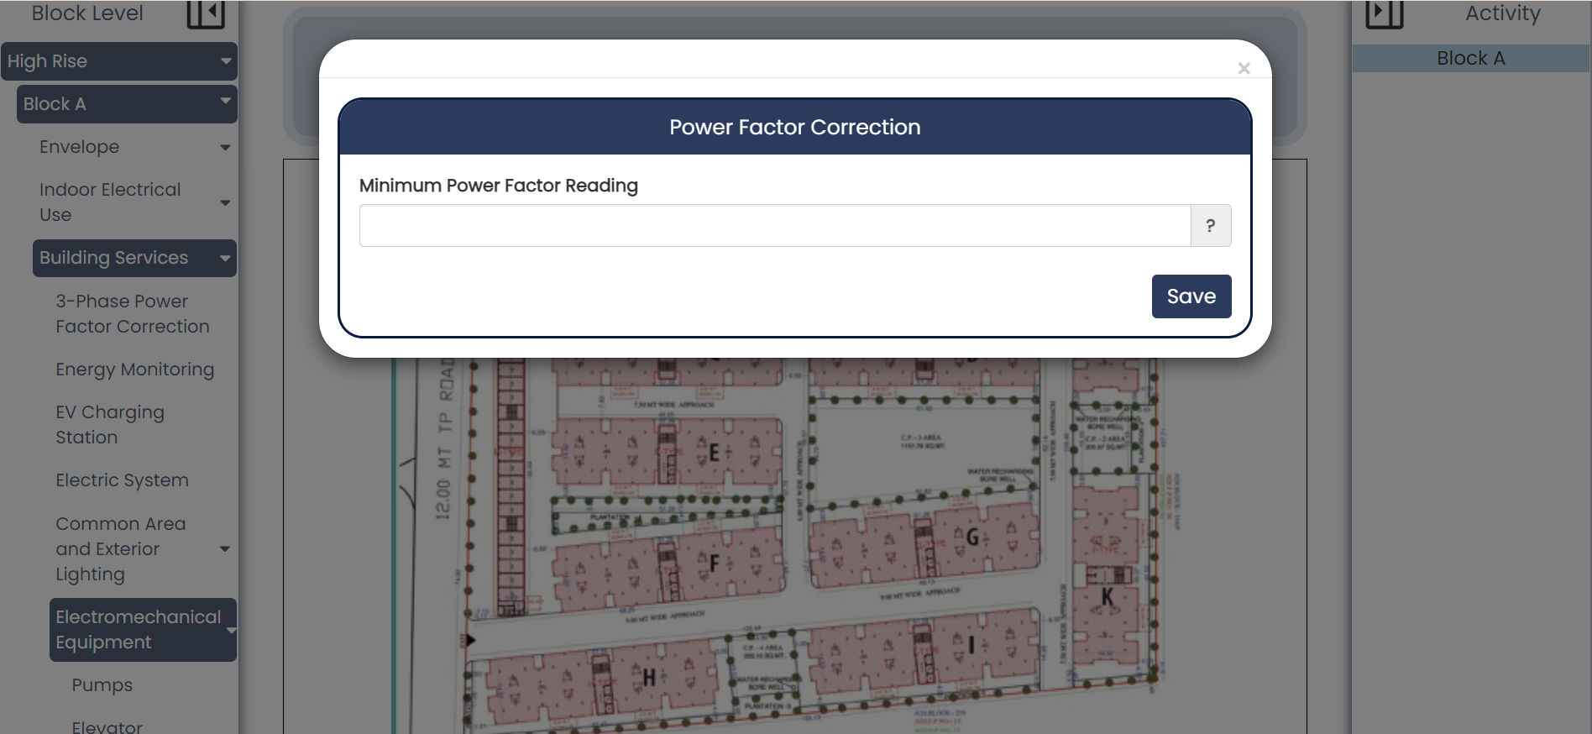
Figure 34 : Adding power factor correction to representative block
- Minimum Power Factor Reading: This field requires number input up to 2 decimal places. Users must provide minimum power reading according to their building specifications.

Energy Monitoring:
Energy monitoring in residential buildings is becoming increasingly important due to the rising awareness of energy conservation and the need to reduce carbon footprints.
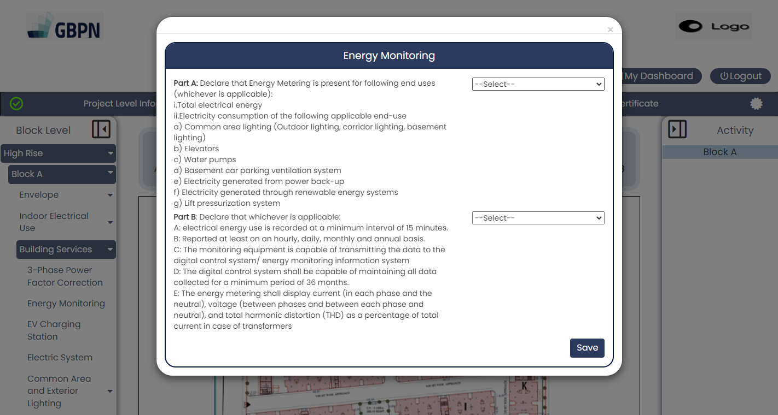
Drag and drop item onto canvas
Figure 35 : Add energy monitoring to representative block
Both Part A and Part B fields are specified in ENS Code for Residential buildings 2024. Users must select ‘Yes’ or ‘No’ according to their building specifications.
EV Charging Station:
Drag and drop item onto block canvas
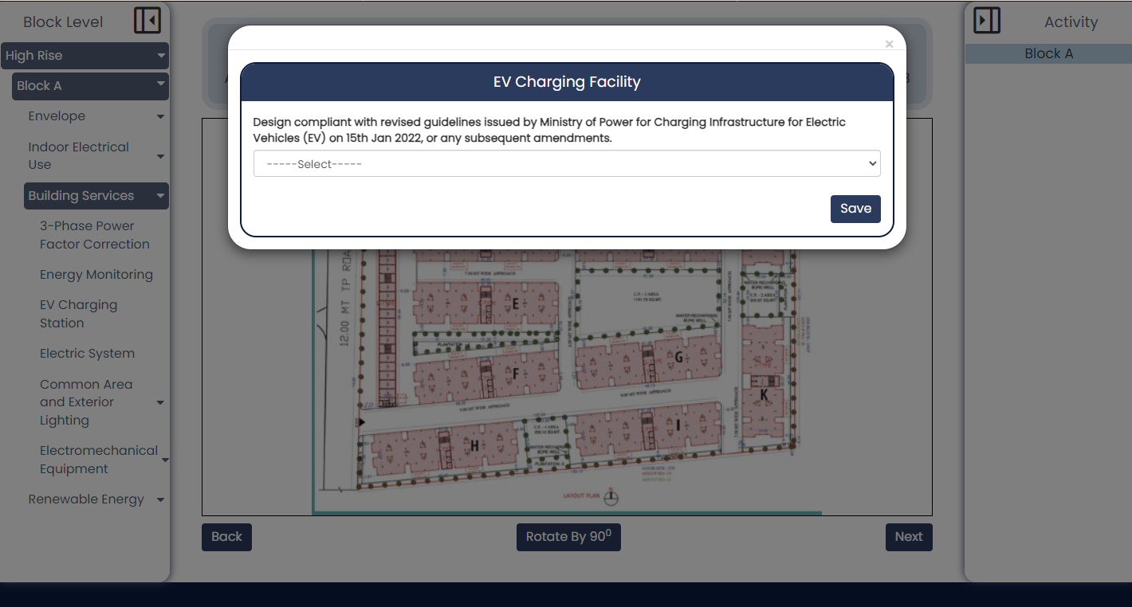
Figure 36 : Add EV Charging facility to representative block
Select yes/no w.r.t design compliant fields in the EV charging facility form to determine whether the building infrastructure conforms to the guidelines established by the Ministry of Power.
Electric System:
Drag and drop in onto block canvas

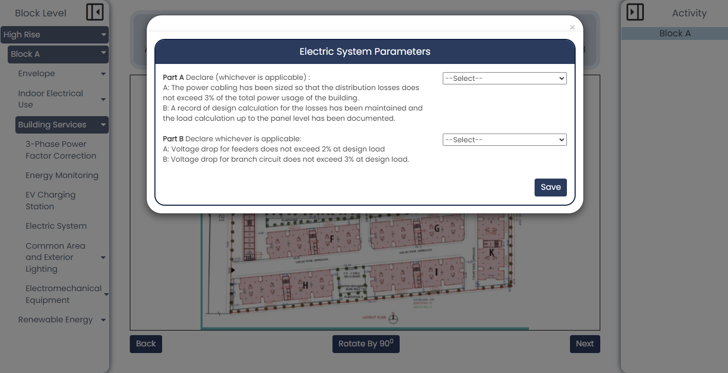
Figure 37 : Add electric system to representative block
Both Part A and Part B fields in this form are specified in ENS Code for Residential buildings 2024. Users must select ‘Yes’ or ‘No’ according to the building specifications.
Common Area Lighting – Corridor and Stilt Parking:
Corridor parking: Parking spaces situated along the corridors of a building, typically on each floor, to provide convenient access for residents or occupants.
Stilt parking: Covered parking spaces located at ground level but elevated above the ground floor, often found in buildings with limited space, allowing for vehicle storage without obstructing ground-level activities.

Drag and drop item onto block canvas
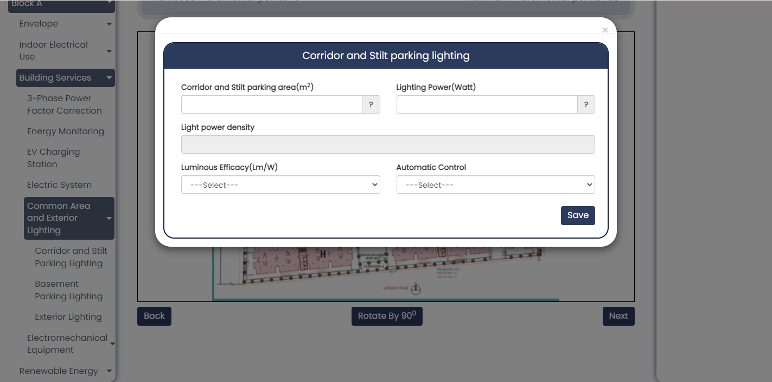
5
4
3
2
1
Figure 38 : Add corridor and stilt parking to representative block
- Corridor and stilt parking area: Enter corridor and stilt parking area of the representative block. This is a mandatory field.
- Lighting Power (Watt): Enter lighting power in watts for the representative block. This is a mandatory field.
- Light Power density: This will be auto calculated based on area and lighting power in above fields.
- Luminous efficacy: Select range from dropdown options in which luminous efficacy value lies w.r.t representative block. This is a mandatory field.
- Automatic Control: Select from dropdown options (astronomical, photo-sensor, not available) according to applicability in the block structure. This is a mandatory field.
Common Area Lighting – Basement Parking:
Basement parking in residential buildings refers to designated parking areas constructed below ground level, providing residents with secure and often covered parking spaces.
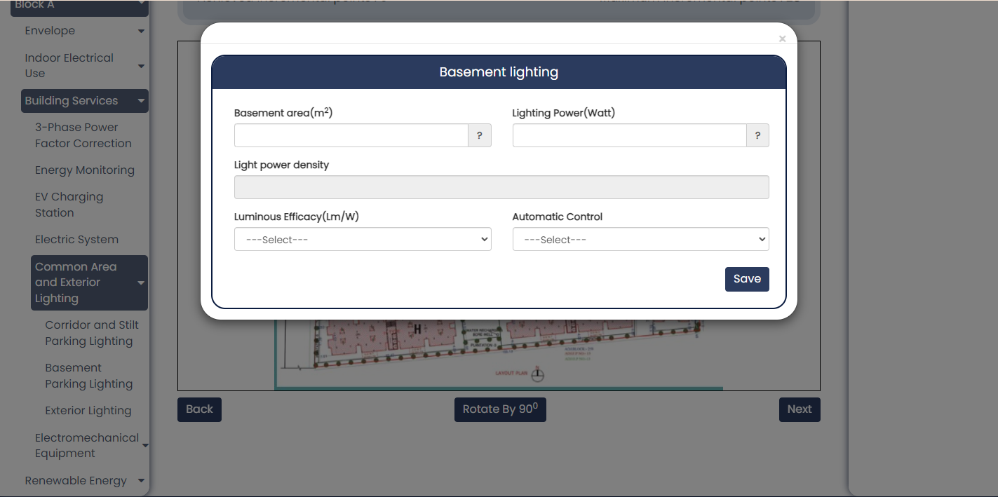
Drag and drop item onto block canvas
4
5
3
2
1
Figure 39 : Add basement parking to representative block
- Basement area: Enter corridor and stilt parking area of the representative block. This is a mandatory field.
- Lighting Power (Watt): Enter lighting power in watts for the representative block. This is a mandatory field.
- Light Power density: This will be auto calculated based on area and lighting power in above fields.
- Luminous efficacy: Select range from dropdown options in which luminous efficacy value lies w.r.t representative block. This is a mandatory field.
- Automatic Control: Select from dropdown options (astronomical, photo-sensor, not available) according to applicability in the block structure. This is a mandatory field.

Common Area Lighting – Exterior Lighting:
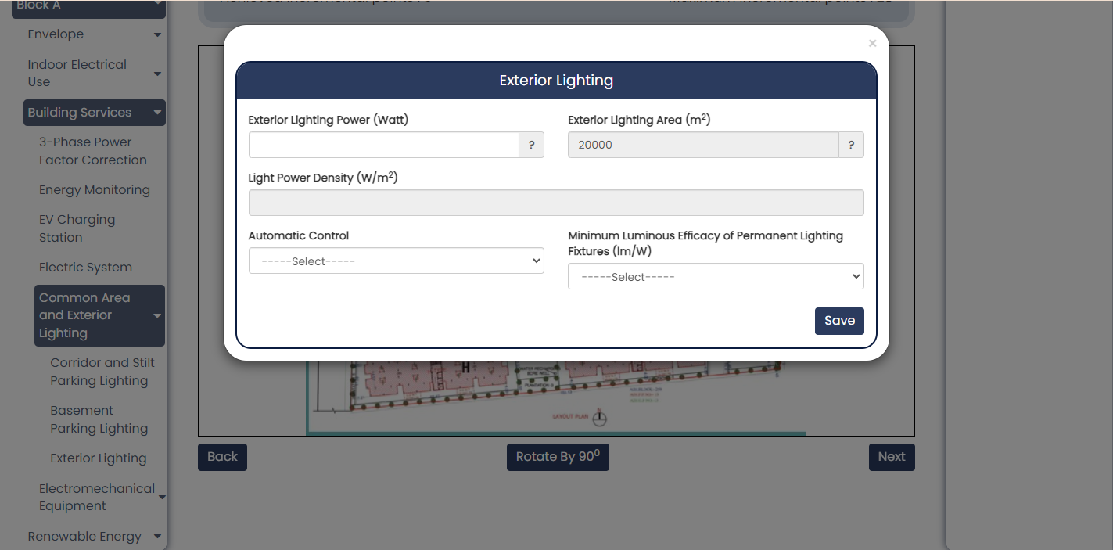
Drag and drop item onto block canvas
5
4
3
2
1
Figure 40 : Add exterior lighting to representative block when area less than equal to 100
In case of lighting power less than and equal to 100 watt, above form will show.
- Exterior parking area: Enter exterior parking area of the representative block. This is a mandatory field.
- Exterior Lighting Power (Watt): Enter lighting power in watts for the representative block. This is a mandatory field.
- Light Power density: This will be auto calculated based on area and lighting power in above fields.
- Luminous efficacy: Select range from dropdown options in which luminous efficacy value lies w.r.t representative block. This is a mandatory field.
- Automatic Control: Select from dropdown options (astronomical, photo-sensor, not available) according to applicability in the block structure. This is a mandatory field.
In case if the lighting power is greater than 100 watt, then below form will be seen by the user.
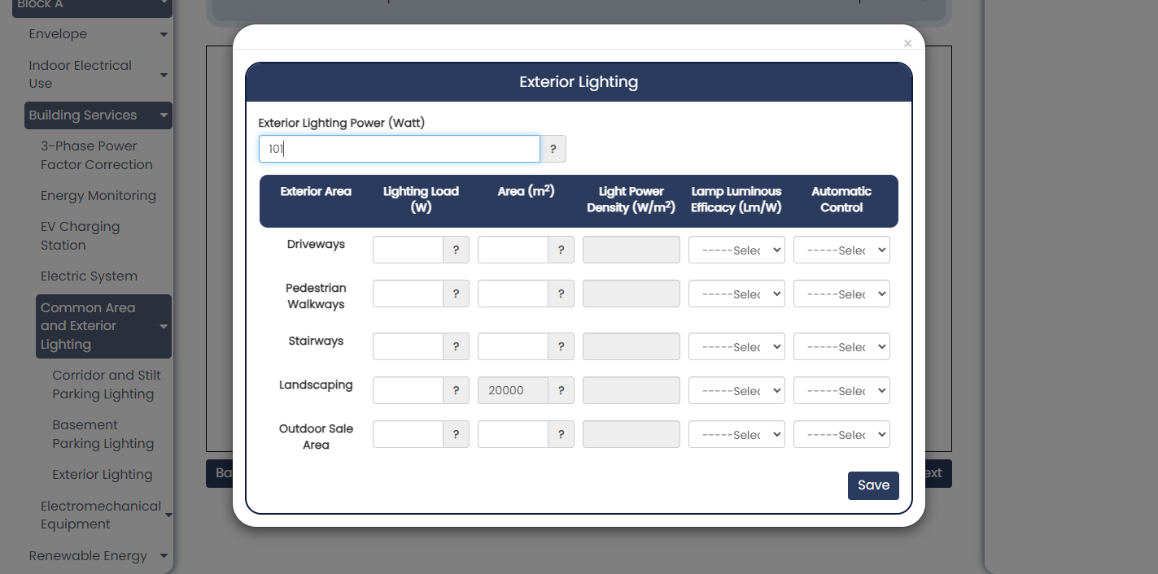
5
4
3
2
1
Figure 41 : Add exterior area to representative block when area greater than 100
- Lighting Load: Enter load (watt) for each of the exterior parameter - driveways/ pedestrian/ stairways/ landscaping/ outdoor sale.
- Area(m²): Enter area value for each of the exterior parameter - driveways/ pedestrian/ stairways/ landscaping/ outdoor sale.
- Light power density: This field will be auto calculated based on load and area for each exterior parameter - driveways/ pedestrian/ stairways/ landscaping/ outdoor sale.
- Lamp luminous efficacy (Lm/w): Select range in which luminous efficacy lies for each of the exterior parameter - driveways/ pedestrian/ stairways/ landscaping/ outdoor sale.
- Automatic Control: Select automatic control among astronomical / photo sensor/ not available for each of the exterior parameter - driveways/ pedestrian/ stairways/ landscaping/ outdoor sale.
Electromechanical Equipment – Pumps:
In a residential building, a pump typically refers to a mechanical device used to facilitate the movement of water or other fluids throughout the building's plumbing system. Pumps are commonly employed for tasks such as supplying water to faucets, showers, and appliances, as well as for wastewater removal and circulation in heating or cooling systems.
Drag and drop item onto block canvas
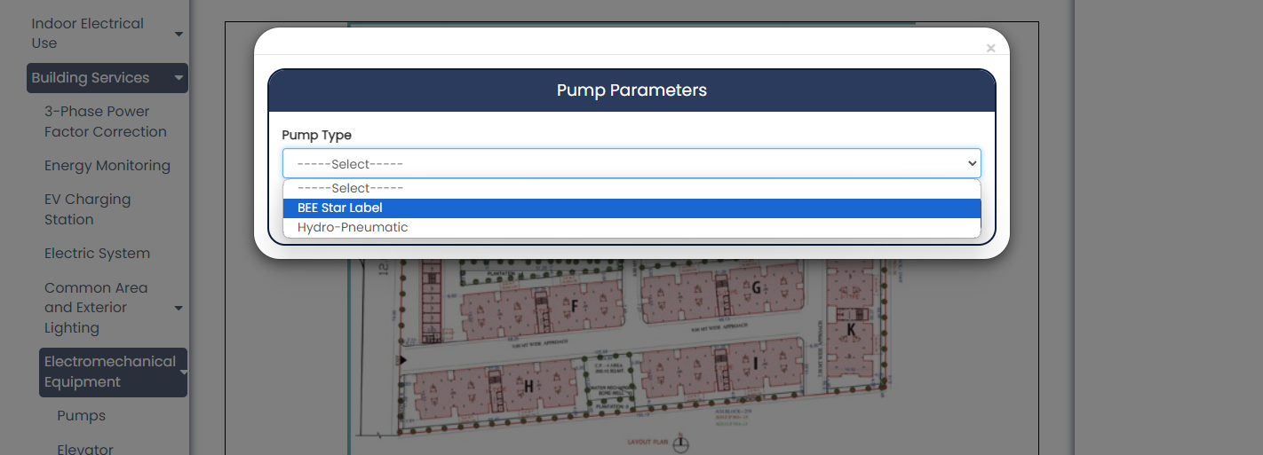
Figure 42 : Form to add pumps to a representative block
    - Pump Type: Select between BEE star label or Hydro-pneumatic whichever is applicable to this representative block.
In case of BEE star label, below field will appear.
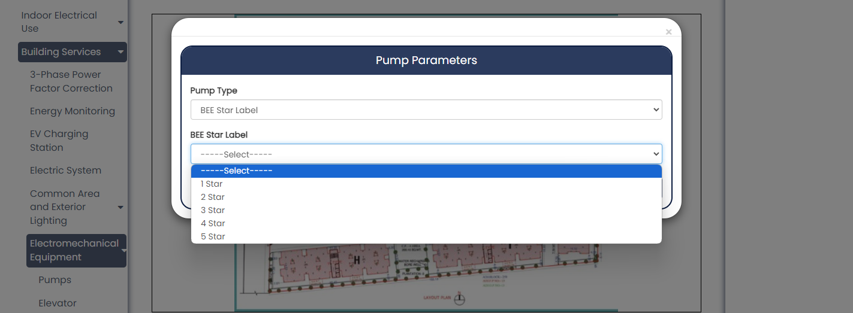
2
1
Figure 43 : Adding BEE star label pump type
    - BEE star label: Select among 1 to 5 star that is applicable to representative block.
In case of Hydro-pneumatic, below field will appear.

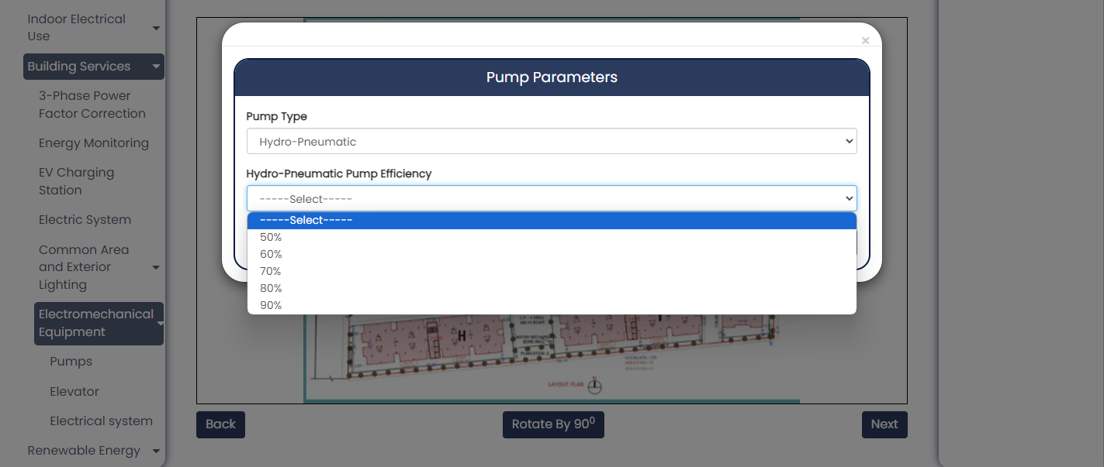
3
Figure 44 : Adding hydro-pneumatic pump efficiency pump type
    - Hydro-Pneumatic pump efficiency: Select between 50% to 90% efficiency according to registered representative block.
Electromechanical Equipment – Elevators:
Drag and drop item onto block canvas
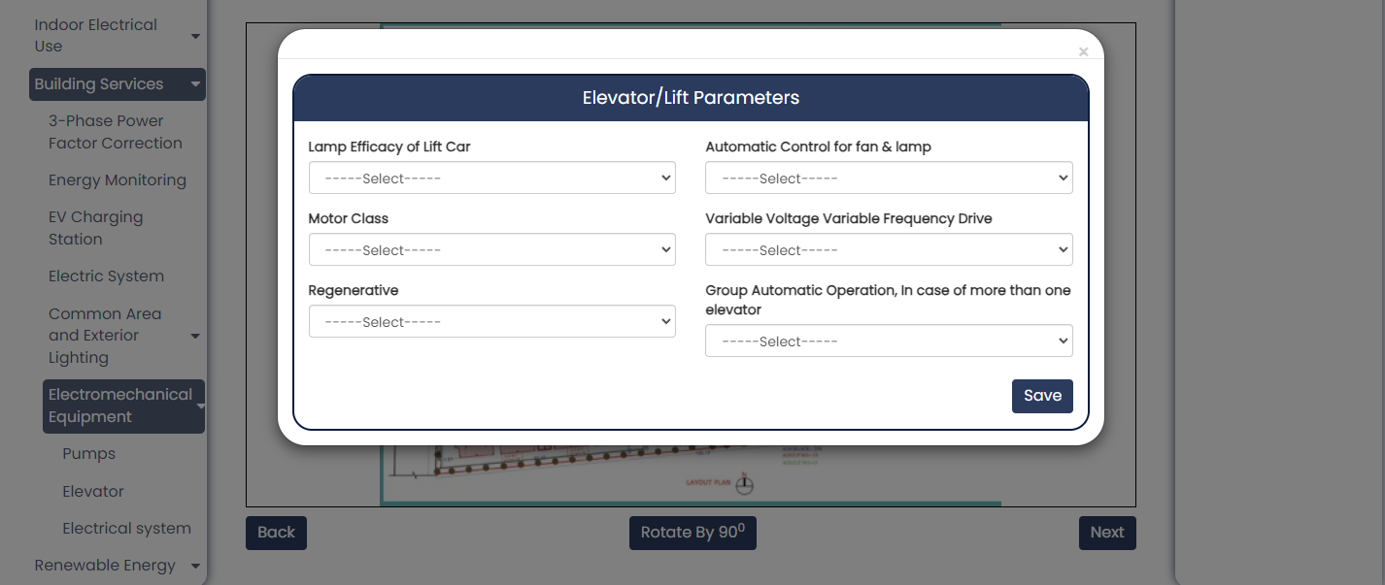
6
5
4
3
2
1
Figure 45 : Adding elevators to representative block
- Lamp Efficacy of lift car: Determine efficacy of lift car and select appropriate range in the dropdown field. This is mandatory input.
- Automatic control for fan & lamp: Select ‘Yes’ / ‘No’ for automatic control in case of fan and lamp according to representative block specifications.
- Motor Class: Select motor class in dropdown field with options IE1, IE2, IE3, IE4, IE5, IE6.
- Variable Voltage Variable Frequency Drive: Select ‘Yes’/’No’ based VVVF installation in the representative block.
- Regenerative: Select ‘Yes’/’No’ whether regenerative property is added in case of elevators in the representative block. Regenerative property in residential building elevators harnesses excess energy during braking or descent for electrical power generation.
- Group Automatic Operation: Select ‘Yes’ / ‘No’ whether group automatic operation system is installed in case of more than one elevator. This system ensures that the elevators operate seamlessly, minimizing waiting times and optimizing the flow of traffic, especially during peak hours or when there is high demand.
Electromechanical Equipment – Electrical System:
Drag and drop item onto block canvas
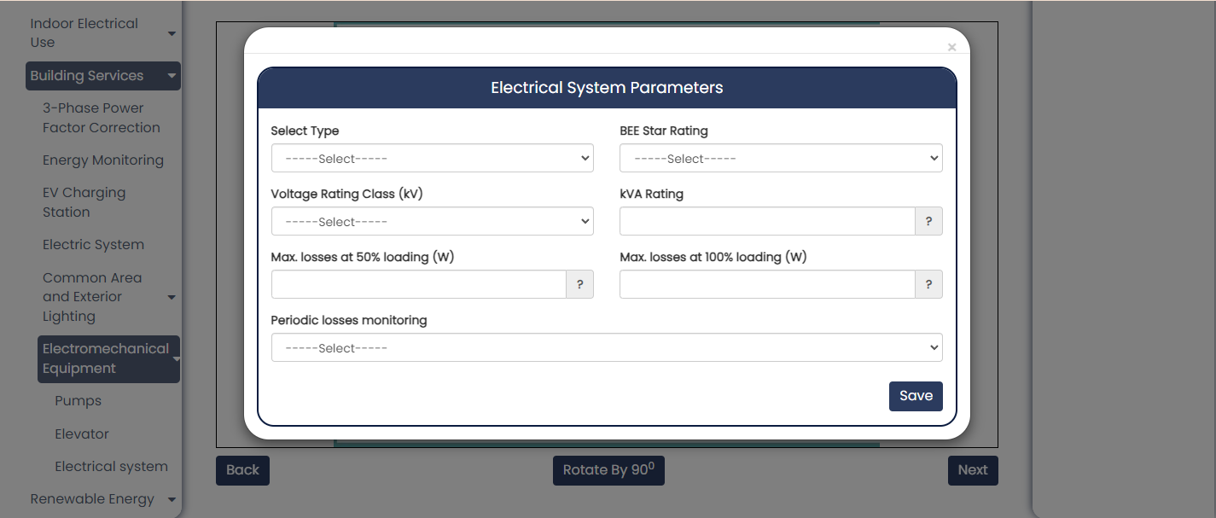
6
7
5
4
3
2
1
Figure 46 : Adding electrical system to a representative block
- Select Type: Choose the type of electrical system installed in the building. There are two options given in the dropdown field – Oil Type / Dry Type.
- BEE star rating: This field is applicable only in the case of oil type systems. Select star rating value of the electrical system installed and choose appropriate option in dropdown field.
- Voltage rating class(kV): Determine voltage rating class of the system and select option from 11kV / 22 kV / 33 kV.
- kVA rating: Enter kVA (kilo-volt-ampere) rating of an electrical system according to block specifications. This field will accept number input up to 2 decimal places.
- Max. losses at 50% loading: Enter maximum amount of power lost within the electrical system installed in this block when it is operating at 50% of its maximum load capacity.
- Max. losses at 100% loading: Enter maximum amount of power lost within the electrical system installed in this block when it is operating at 100% of its maximum load capacity.
- Periodic losses monitoring: Select 'yes' / 'no' whether regularly assessing and recording the losses that occur within the system installed in the building.

Renewable Energy
Solar Hot Water System:
Drag and drop item onto block canvas

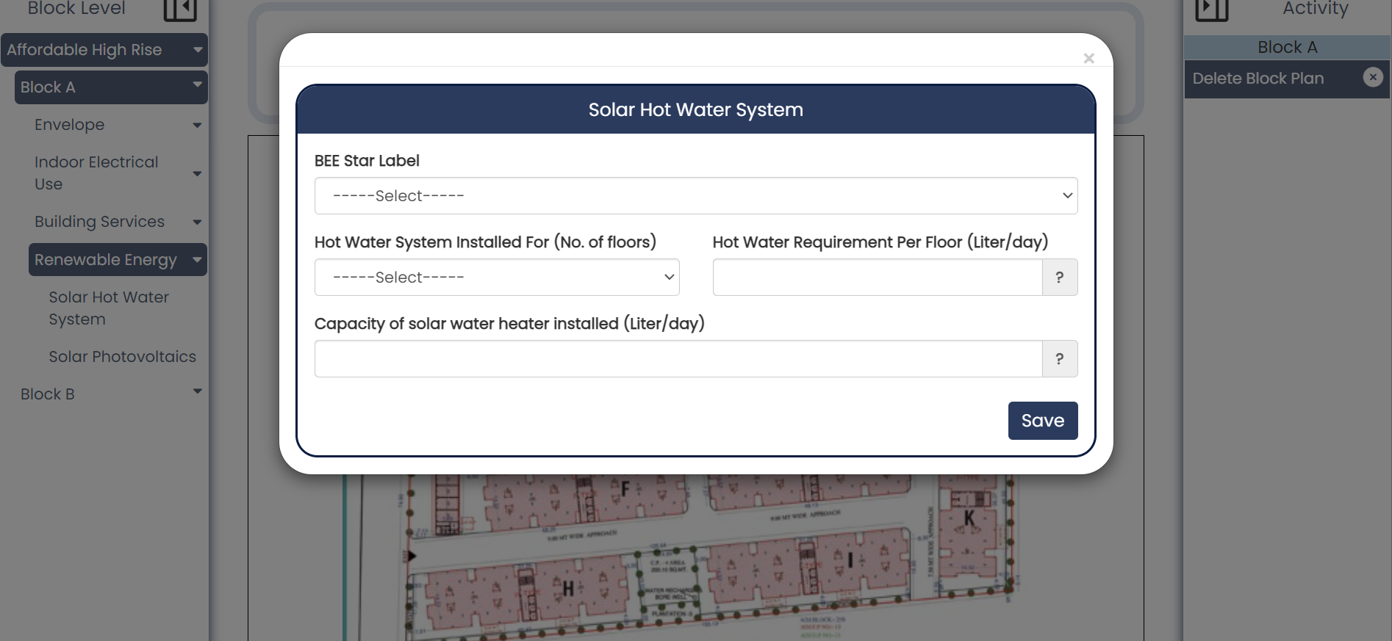
2
4
3
1
Figure 47 : Adding solar hot water system to a representative block
- BEE star label: Select star rating from 1 to 5 stars according to solar hot water system installed at the building site.
- Hot water system installed for no. of floors: Select up to 4, 6, or 8 floors for which the hot water system is installed.
- Hot water requirement per floor: Enter value in liters for the water consumption per floor per day. Data is accepted up to 2 decimal places.
- Capacity: Enter the maximum amount of hot water that the solar water heater system installed in the building can produce in a single day.
Solar Photovoltaic System:
Drag and drop this item to block canvas

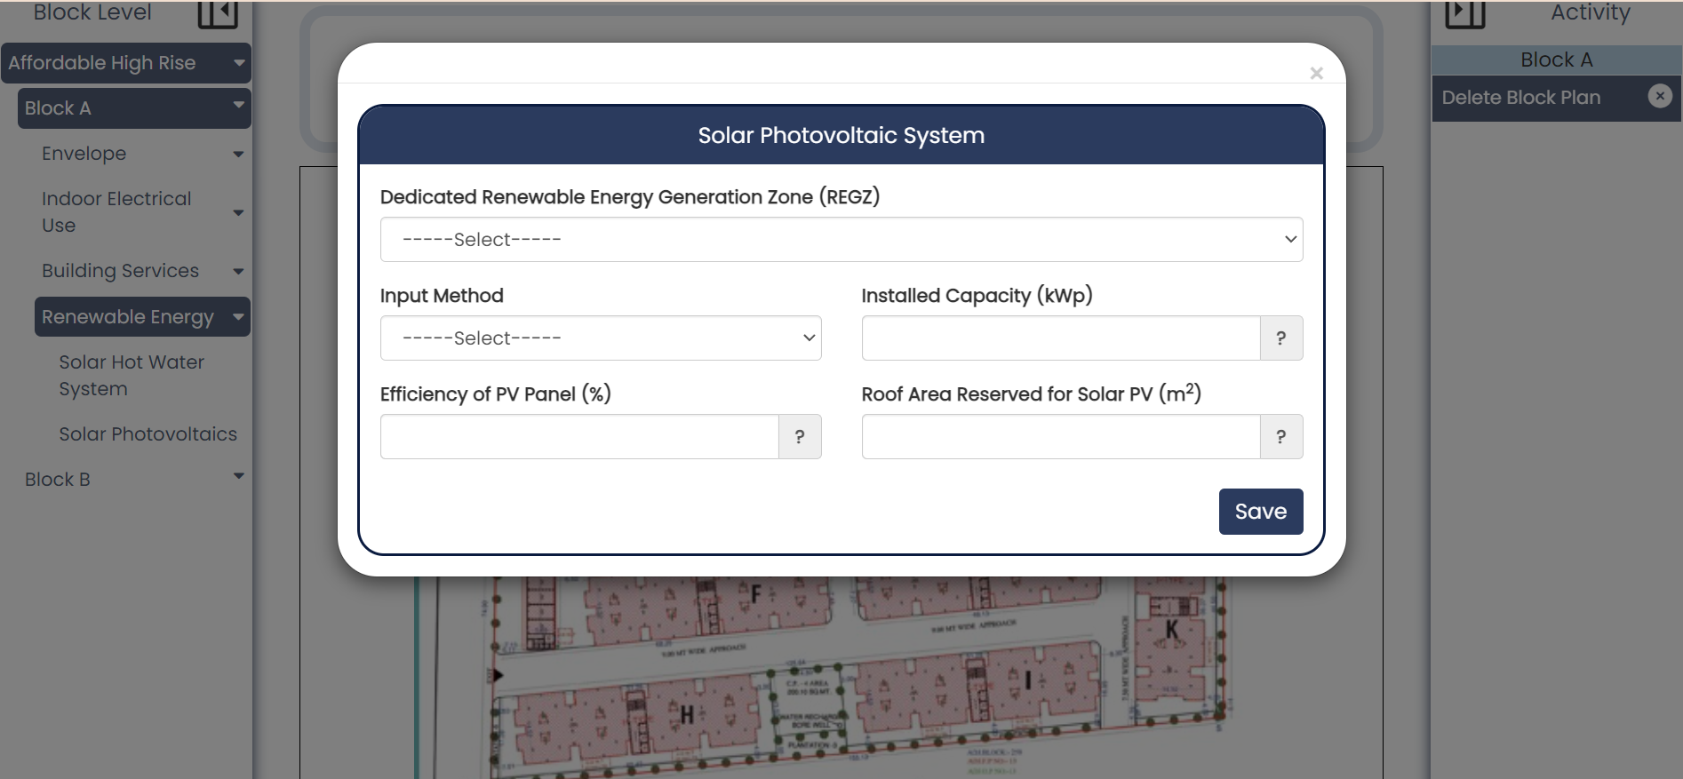
5
4
3
2
1
Figure 48 : Adding solar photovoltaic system to a representative block
    - Dedicated Renewable Energy Generation Zone (REGZ): Select ‘Yes’ / ‘No’ whether area specifically designated and developed for the purpose of generating renewable energy.
    - Input Method: The "input method" in solar photovoltaic systems for residential use refers to how the system's capacity or output is defined or described. User must choose from two options given –
- Roof equivalent: This method measures the solar panel system's capacity or output in terms of the equivalent area of roof space required to generate the same amount of electricity.
- Electricity equivalent: This method measures the system's capacity or output directly in terms of electrical power.
    - Installed capacity: Enter capacity (in kWp) of system installed to generate electricity. This field takes number input up to 2 decimal places.
    - Efficiency of PV Panel: Enter efficiency in percentage of the solar photovoltaic system installed in the building.
    - Roof Area reserved for solar PV: Enter area (in m²) of portion of the building's roof that is designated or set aside specifically for the installation of solar photovoltaic (PV) panels.

Certificate Level Information
Users will access the certificate level tab by clicking the 'Next' button on the block level. Only when walls (in all directions) and a roof are added for every block, users will be directed to the certificate tab. Otherwise, a dialog box, as shown below, will appear.
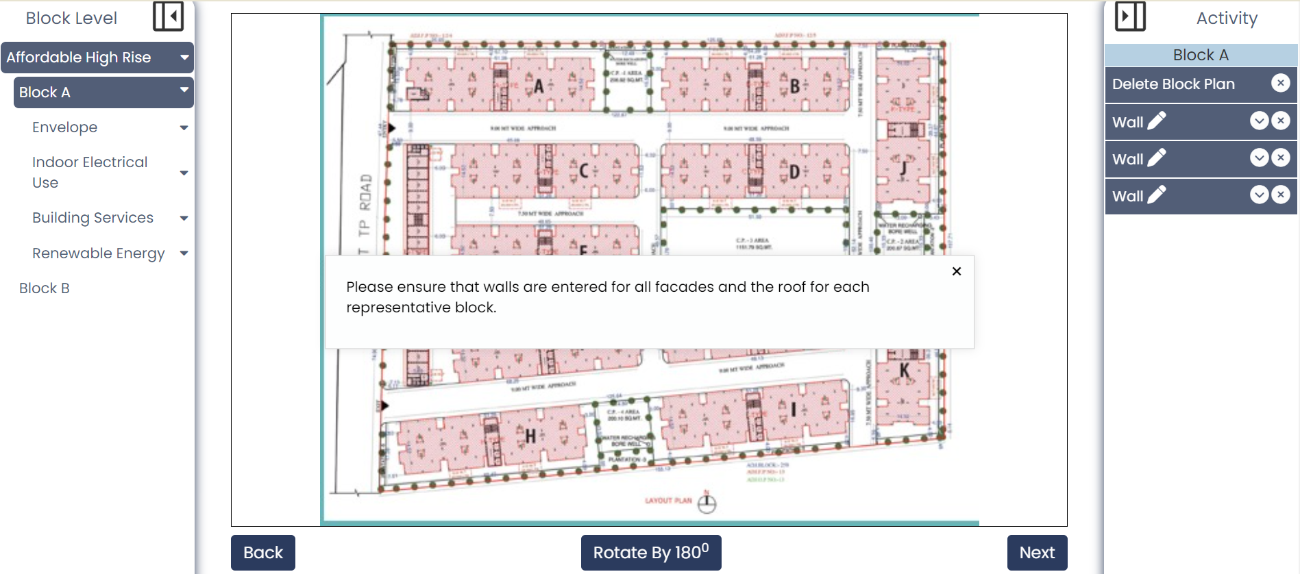
Figure 49 : Dialog box appears if walls and roof are not added in every representative block

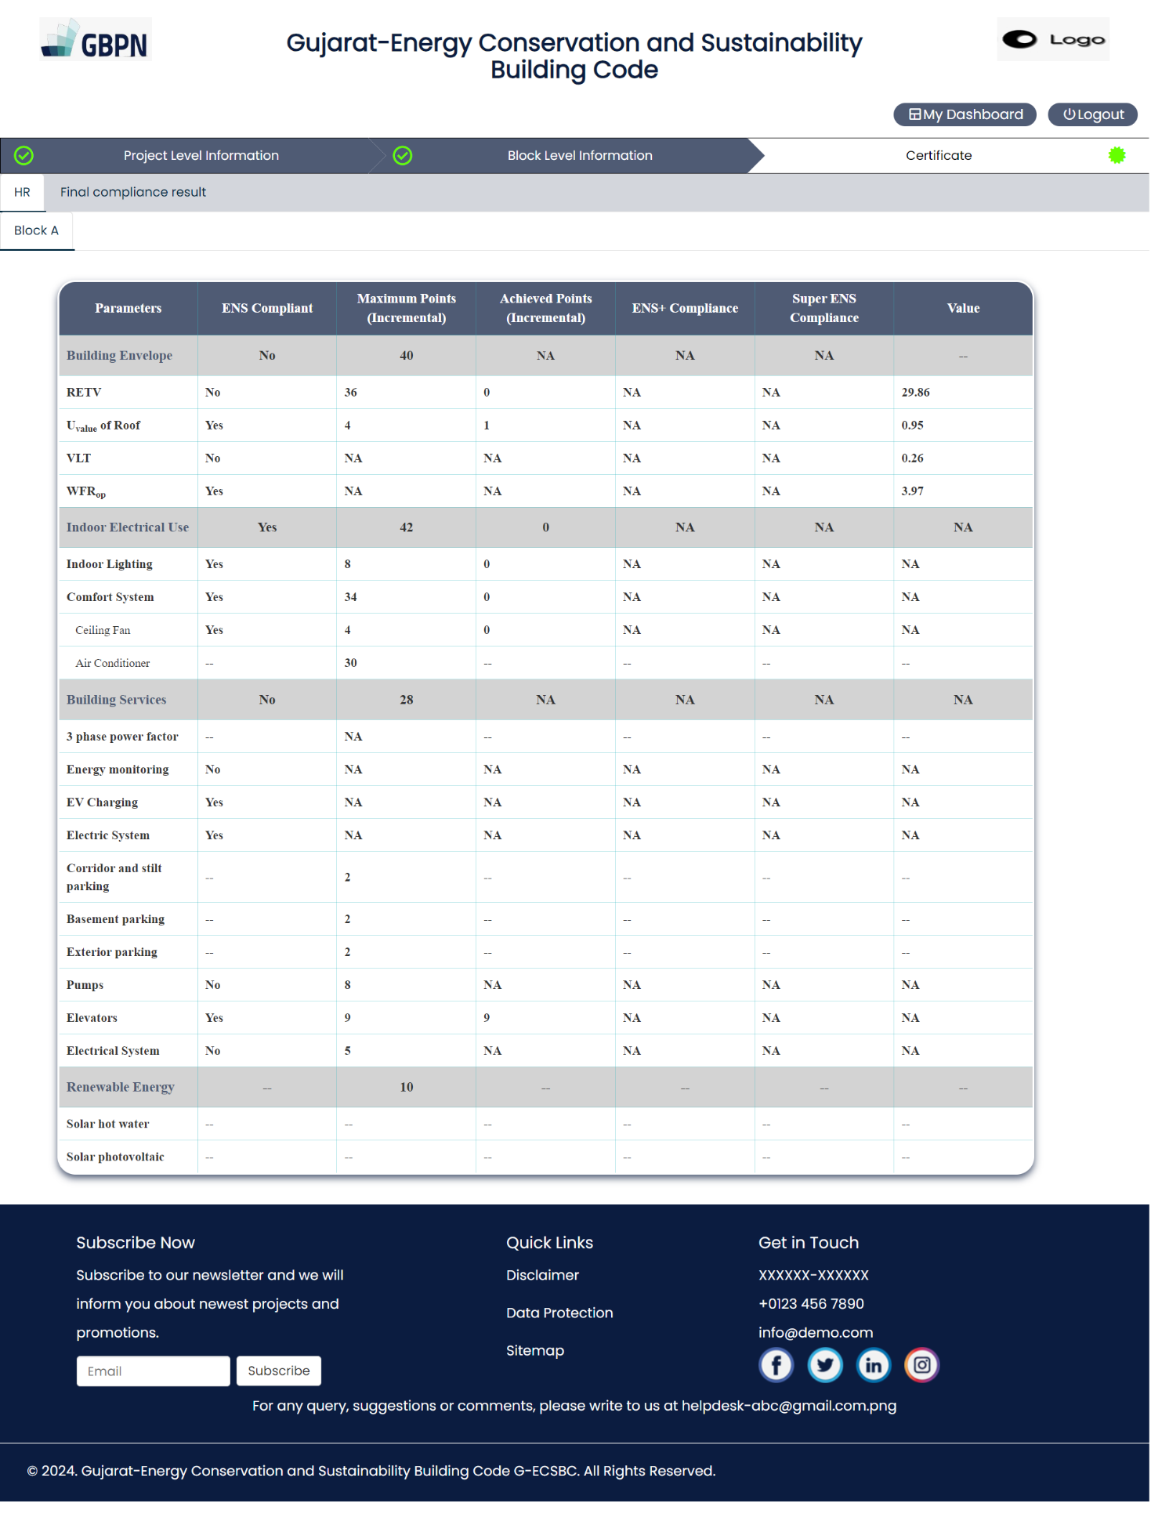
Figure 50 : Certificate level display of each representative block
The page displays a table in the Certificate tab, presenting detailed information categorized under specific housing blocks. Users can navigate between different blocks by clicking on tabs corresponding to their names.
For instance, a block includes components such as walls in all directions, roof, indoor lighting, ceiling fan, pumps, elevator, and electrical system. Based on the values filled in the forms, if the ENS (Energy and Sustainability) Compliance is affirmed as 'Yes', applicable points will be displayed to the user. Additionally, the total points for all parameters will be presented against each section, including Building Envelope, Indoor Electrical Use, Building Services, and Renewable Energy, as illustrated in the figure below.
Note: To ensure compliance in the 'Building Envelope' section of any representative block, users must include windows in that block.

Final Compliance Result:
Users can download the generated certificate by clicking on ‘Generate Certificate’ button as shown below.
Final compliance from all sections will be shown here

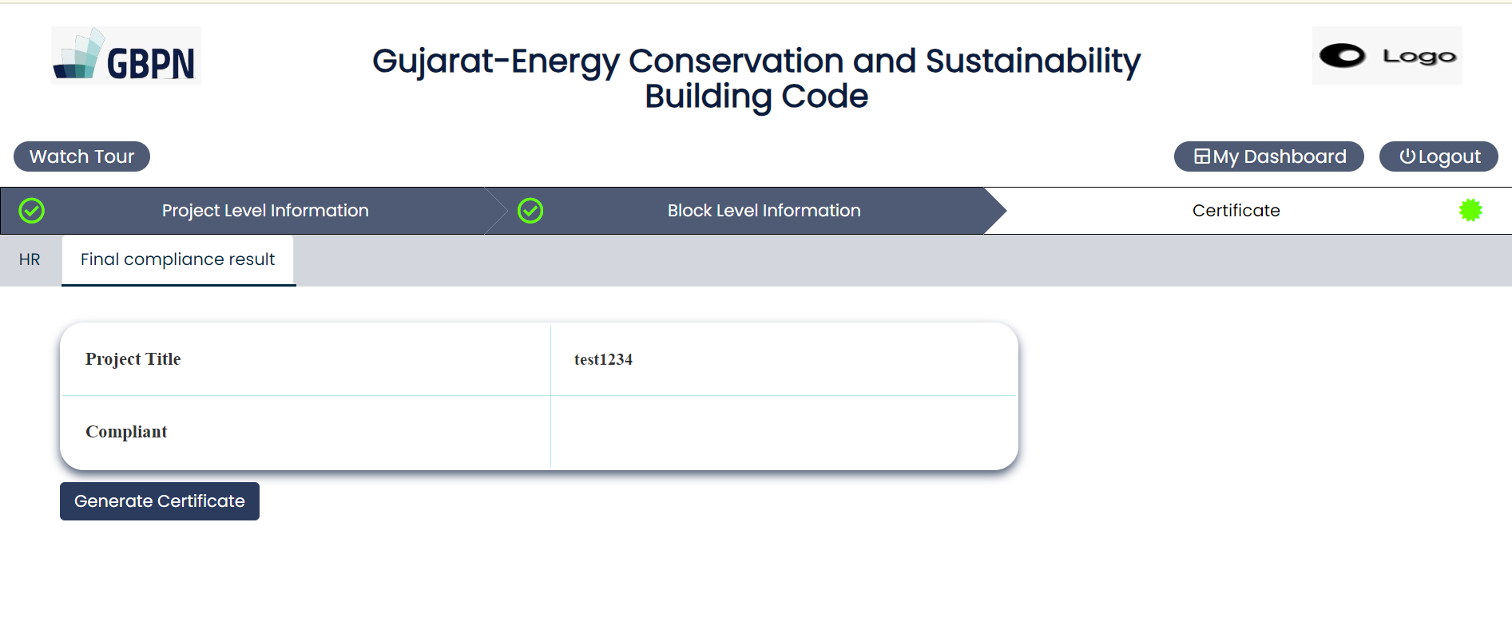
Figure 51 : ‘Generate Certificate’ button to download compliance certificate

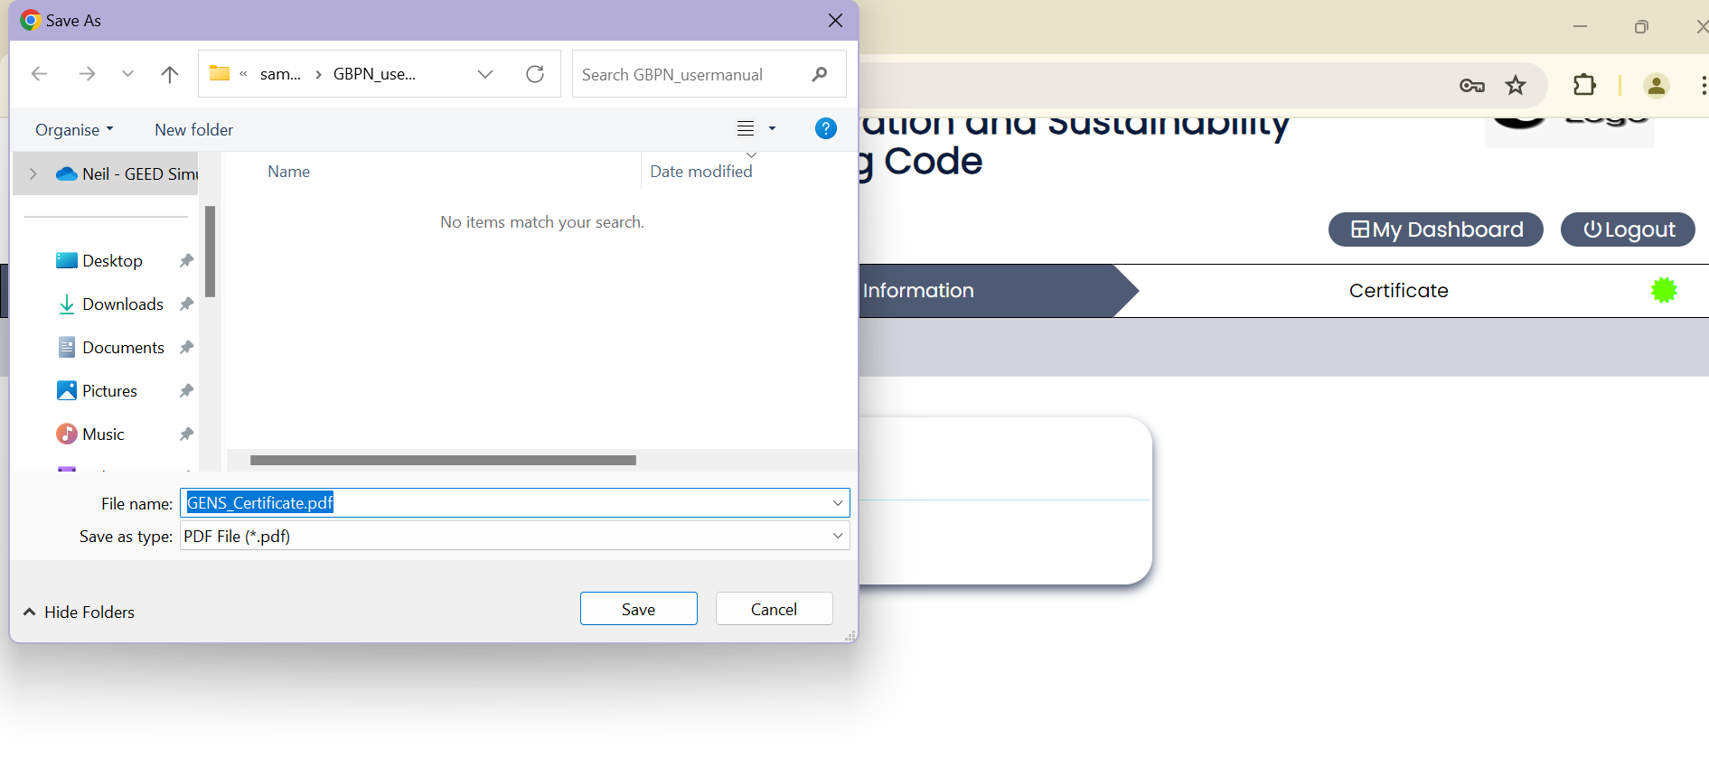
Figure 52 : Figure showing example certificate getting downloaded

From the above figure, as mentioned previously, pdf file will automatically get downloaded.

